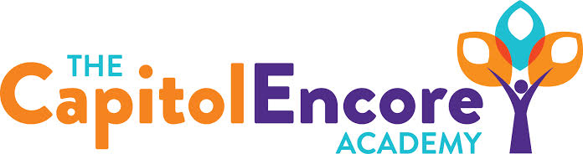

“Learning the Art of Success Every day!”

ENCORE BOARD OF DIRECTORS

Mission Statement
The Capitol Encore Academy will develop artists who inspire others with principles of design and artful thinking through the integration of academic excellence, virtuous character and disciplined artistry.
December 19, 2016 Meeting Minutes

The Capitol Encore Academy
126 Hay Street
Fayetteville, NC 28301

Call to Order By: J. Fiebig At: 5:15pm

Roll Call R. Poole Absent

S. Barnard Present

J. Fiebig Present

W. Hustwit Present

S. Angarita Present

U. Taylor Absent

M. Brand Absent

A. Thornberg Present 5:21

T. Hinds Present

Pledge of Allegiance

Approval of Agenda Motion by S. Barnard seconded by W. Hustwit to approve the agenda.

Y-5 N-0

Motion Carries

Consent Items Motion by W. Hustwit seconded by S. Angarita to approve the minutes from the December 19, 2016 Regular Meeting.

Y-5 N-0

Motion Carries

Motion by W. Hustwit seconded by S. Angarita to approve November Financial Report.

Y-5 N-0

Motion Carries

Board Committee None

Family Educator Org None

Report

Admin Report Discussed the expansion of the MTSS program

Described the upcoming Title I audit

Update on the School Improvement Conference & discussed Collaborative Conference

Discussion Items Updated on Teacher of the Year process

Discussed new Board Member orientation packet

Update on make up days

Board requested that policies are assembled

Action Items None

Call to the Public Visual arts teacher requested donors choose donation

Media Arts teacher requested consideration for additional tech needs

Board Member commented on Awards Assembly going smoothly.

40 under 40 sponsorship opportunities discussed

Announcements The next Board of Director’s meeting will be held on January 23, 2017 5:15pm.

Adjournment Motion By: Seconded By: Time:

S. Barnard A. Thornberg 5:56

