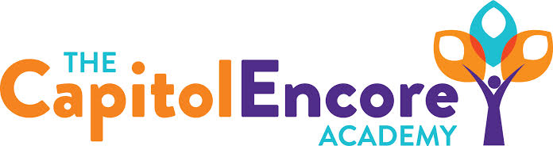

“Learning the Art of Success Every day!”

ENCORE BOARD OF DIRECTORS

Mission Statement
The Capitol Encore Academy will develop artists who inspire others with principles of design and artful thinking through the integration of academic excellence, virtuous character and disciplined artistry.
February 27, 2017 Meeting Minutes

The Capitol Encore Academy
126 Hay Street
Fayetteville, NC 28301

Call to Order By: J. Fiebig At: 5:18pm

Roll Call R. Poole Present 5:51

S. Barnard Absent

J. Fiebig Present

W. Hustwit Present

S. Angarita Present

U. Taylor Present, departed 6:08

M. Brand Present

A. Thornberg Present

T. Hinds Absent

Pledge of Allegiance

Approval of Agenda Motion by W. Hustwit seconded by A. Thornberg to approve the agenda with amendments.

Y-6 N-0

Motion Carries

Consent Items Motion by U. Taylor seconded by W. Hustwit to approve the minutes from the January 23, 2017 Regular Meeting.

Y-6 N-0

Motion Carries

Motion by W. Hustwit seconded by U. Taylor to approve January Financial Report.

Y-6 N-0

Motion Carries

Financial Audit Presentation of the 2015-2016 Financial Audit by Rives

Board Committee Curriculum Committee- M. Brand updated on K-2 Phonics Training, teachers in January chose their own PD. Continuing MTSS and PLCs.

Family Educator Org None

Report

SIT Report Positive comments from the DPI coach were shared, working on 2 additional indicators.

Admin Report Discussed Summer School Plan and that the plan would need to be approved in the March meeting.

Reviewed reenrollment numbers, at or ahead of last year’s pace.

Presented discipline data for the month.

March will go into closed session to discuss those not being asked back.

Reviewed academic growth.

Discussion Items Discussed the audit process and how things can be improved upon in the upcoming years.

Action Items Motion by M. Brand seconded by W. Hustwit to accept financial audit as presented.

Y-6 N-0

Motion Carries

Motion by J. Fiebig seconded by W. Hustwit to have Board Committee review audit progress and update Board Aug-Oct of upcoming year.

Y-6 N-0

Motion Carries

Call to the Public None

Announcements The next Board of Director’s meeting will be held on March 20, 2017 5:15pm.

Adjournment Motion By: Seconded By: Time:

W. Hustwit M. Brand 6:28

