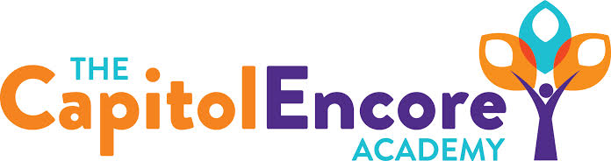

“Learning the Art of Success Every day!”

ENCORE BOARD OF DIRECTORS

Mission Statement
The Capitol Encore Academy will develop artists who inspire others with principles of design and artful thinking through the integration of academic excellence, virtuous character and disciplined artistry.
March 20, 2017 Meeting Minutes

The Capitol Encore Academy
126 Hay Street
Fayetteville, NC 28301

Call to Order By: J. Fiebig At: 5:16pm

Roll Call R. Poole Present

S. Barnard Present

J. Fiebig Present

W. Hustwit Absent

S. Angarita Absent

U. Taylor Present 5:28

M. Brand Present

A. Thornberg Present

T. Hinds Present 5:20

Pledge of Allegiance

Approval of Agenda Motion by J. Poole seconded by S. Barnard to approve the agenda with amendments.

Y-5 N-0

Motion Carries

Consent Items Motion by J. Poole seconded by M. Brand to approve the minutes from the February 27, 2017 Regular Meeting.

Y-5 N-0

Motion Carries

Motion by J. Poole seconded by M. Brand to approve February Financial Report.

Y-5 N-0

Motion Carries

Board Committee Curriculum Committee- Discussed Festival of Trees for the 17/18 school year, Brand and Hill will coordinate.

Family Educator Org None

Report

SIT Report SIT members attended School Improvement Boot Camp, one focus was on TLAC strategies and how to implement with Fidelity. Mr. Klein has created bi-laws for Student Council.

Admin Report Presented Summer School options

Discussed EOG preparation including schedule and need for Proctors

Discussed job fairs including Campbell, UNC and in house TCEA.

Hill presented updated data, discipline, enrollment and observation findings.

Discussion Items Discussed creating a policy for visitors using restrooms. Will invesatigate possibility of creating multiple single use bathrooms out of a gang bathroom.

Staff helped prepare school calendar which will be presented in April.

Art park project April 8th & 9th, could use school volunteers for painting.

Discussed adding 30 day clause to employment contracts.

Closed Session Motion by J. Poole, supported by U. Taylor to go into Closed Session to discuss Human Resource matters. 6:01

Y-7 N-0

Motion Carries

Motion by S. Barnard, supported by A. Thornberg to go back into Open Session. 6:15

Y-7 N-0

Motion Carries

Action Items Motion by A. Thornberg, supported by U. Taylor to approve the Summer School plan as presented.

Y-7 N-0

Motion Carries

Motion by J. Poole, supported by S. Barnard to approve use of IReady as growth assessment.

Y-7 N-0

Motion Carries

Motion by J. Poole, supported by A. Thornberg to approve ESP agreement.

Y-7 N-0

Motion Carries

Motion by J. Poole, supported by U. Taylor to approve Lease Agreement.

Y-7 N-0

Motion Carries

Motion by J. Poole, supported by S. Barnard to approve staffing proposal.

Y-7 N-0

Motion Carries

Call to the Public Prospective parent and advocate spoke to the Board about PFLAG and issue revolving around student diversity.

Announcements The next Board of Director’s meeting will be held on April 24, 2017 5:15pm.

Adjournment Motion By: Seconded By: Time:

U. Taylor S. Barnard 6:25

