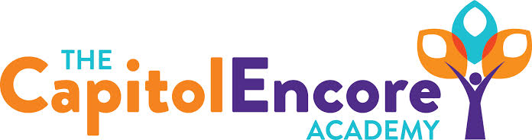

“Learning the Art of Success Every day!”

ENCORE BOARD OF DIRECTORS

Mission Statement
The Capitol Encore Academy will develop artists who inspire others with principles of design and artful thinking through the integration of academic excellence, virtuous character and disciplined artistry.
April 24, 2017 Meeting Minutes
5:15 PM

The Capitol Encore Academy
126 Hay Street
Fayetteville, NC 28301

Call to Order By: J. Fiebig At: 5:23pm

Roll Call R. Poole Absent

S. Barnard Present

J. Fiebig Present

W. Hustwit Present

S. Angarita Present

U. Taylor Present

M. Brand Present

A. Thornberg Present

T. Hinds Present 5:30

Non Board Members A. Hill- Principal

Contributing J. Salisbury- School Nutrition

W. Kneer- Superintendent

Pledge of Allegiance

Approval of Agenda Motion by M. Brand seconded by S. Barnard to approve the agenda with amendments.

Y-6 N-0

Motion Carries

Consent Items Motion by M. Brand seconded by S. Barnard to approve the minutes from the March 20, 2017 Regular Meeting.

Y-6 N-0

Motion Carries

Motion by W. Hustwit seconded by U. Taylor to approve March Financial Report.

Y-6 N-0

Motion Carries

Board Committee Curriculum Committee- M. Brand updated on the DPI visit, positive comments and areas for improvement.

School Nutrition Committee- J. Salisbury discussed the Local Wellness Policy and the changes from FY17 to FY18.

Family Educator Org Penny Wars ongoing

Report

SIT Report Working on state indicators, completed #3. Forming student council for next year.

Admin Report Discussed observations and feedback received from Art Space Visit. Interest in pursuing A+.

EOG Bootcamp- Teachers reviewing what will be on EOG. Pre and post tests showing gains and needs.

Integration Studio Night- Parents felt it was more intereactive and enjoyed the experience. Timing needs to be improved upon.

Discussed Challenge Island Summer Camp

Discussion Items Discussed 2018 School Calendar

Proposed and discussed new hires

Reviewed HS and growth options

Discussed need for Social Media policy for staff

Discussed benefits of Parallel vs Vertical Scheduling

Action Items Motion by S. Barnard, supported by M. Brand to approve the 2018 School Calendar as presented.

Y-7 N-0

Motion Carries

Motion by W. Hustwit, supported by M. Brand to approve hiring of new staff.

Y-7 N-0

Motion Carries

Motion by A. Thornberg, supported by S. Barnard to approve Local Wellness Policy.

Y-7 N-0

Motion Carries

Motion by M. Brand, supported by U. Taylor to delay the start of HS.

Y-7 N-0

Motion Carries

Call to the Public None

Announcements The next Board of Director’s meeting will be held on May 15, 2017 5:15pm.

Adjournment Motion By: Seconded By: Time:

U. Taylor W. Hustwit 7:09

