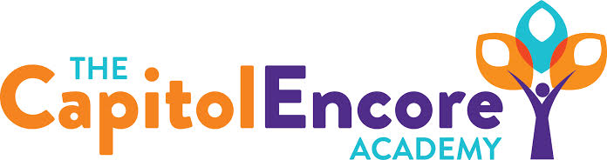

“Learning the Art of Success Every day!”

ENCORE BOARD OF DIRECTORS

Mission Statement
The Capitol Encore Academy will develop artists who inspire others with principles of design and artful thinking through the integration of academic excellence, virtuous character and disciplined artistry.
August 21, 2017 Meeting Minutes
5:15 PM

The Capitol Encore Academy
126 Hay Street
Fayetteville, NC 28301

Call to Order By: R. Poole At: 5:15pm

Roll Call R. Poole Present

S. Barnard Present 5:18

J. Fiebig Present

W. Hustwit Present

S. Angarita Present 5:33

U. Taylor Absent

M. Brand Present

A. Thornberg Present

T. Hinds Present

Non Board Members A. Hill- Principal

Contributing J. Salisbury- School Nutrition

W. Kneer- Superintendent

Pledge of Allegiance

Approval of Agenda Motion by J. Poole seconded by M. Brand to approve the agenda.

Y-6 N-0

Motion Carries

Consent Items Motion by J. Poole seconded by A. Thornberg to approve the minutes from the June 19, 2017 Regular Meeting.

Y-7 N-0

Motion Carries

Motion by J. Poole seconded by A. Thornberg to approve the minutes from the June 19, 2017 Budget Hearing.

Y-7 N-0

Motion Carries

Motion by J. Poole seconded by A. Thornberg to approve July Financial Report.

Y-7 N-0

Motion Carries

Board Committee Curriculum Committee Math Curriculum and development

Family Educator Org None

Report

SIT Report SIT team members gave an update on indicator progress, the creation of Student Council and Development of a student radio station.

Admin Report A. Hill presented Principal Report

Discused the Student Handbook

Presented and discussed the Beginning Teacher Plan

Discussion Items The Board discussed its meeting dates for 2017-2018 and decided upon:

10/16, 11/20, 12/18, 1/22, 2/26, 3/19, 4/16, 5/21,

6/18 & 7/16.

Board discussed Charter Renewal process and timeline.

Action Items Motion by T. Hinds, supported by U. Barnard to approve Handbook.

Y – 8 N – 0

Motion Carries

Motion by T. Hinds, supported M. Brand to approve Beginning Teacher Plan.

Y – 8 N – 0

Motion carries

Motion by J. Poole, supported by A. Thornberg to approve New Hires.

Y – 8 N – 0

Motion carries

Call to the Public None

Announcements The next Board of Director’s meeting will be held on September 18, 2017 5:15pm.

Adjournment Motion By: Seconded By: Time:

W. Hustwit J. Poole 6:22

