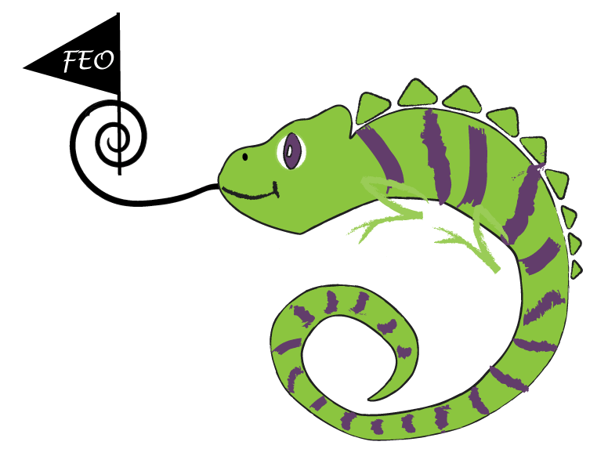
Friends of Encore Organization
Join Us Today!
What is The Capitol Encore Academy FEO?
The FEO funds a plethora of school activities, such as Field Trips, Pep Rallies, Books for Summer Reading, Field Day, Staff Shirts and so much more. We also provide necessary project funding to support teacher needs and student community events.
Each family that donates $5 or more will receive a spirit magnet.
How do I join? – Pay What You Value
Pay What You Value means you pay what you can, wish or want to.
No donation is too big or too small to help make great things happens for the TCEA community.
Want to do MORE?
Join with at least a $5 donation & volunteer at least 5 hours per family and receive a volunteer t-shirt and a Chameleon Perks Pass*!
Please complete the form below and place it, along with your donation in the envelope provided. A Receipt will be sent home with your student. Thank you!
Name: __________________________________________________________________________________________
Child's Name: ____________________________________________________________________________________
Grade(s): _____________________ Teacher(s): _________________________________________________________
Phone: ___________________________Email: _________________________________________________________
Amount Enclosed $____________________ Cash/Check (circle one)
*More details coming soon about our all new Chameleon Perks Pass!

Friends of Encore Organization
Join Us Today!
What is The Capitol Encore Academy FEO?
The FEO funds a plethora of school activities, such as Field Trips, Pep Rallies, Books for Summer Reading, Field Day, Staff Shirts and so much more. We also provide necessary project funding to support teacher needs and student community events.
Each family that donates $5 or more will receive a spirit magnet.
How do I join? – Pay What You Value
Pay What You Value means you pay what you can, wish or want to.
No donation is too big or too small to help make great things happens for the TCEA community.
Want to do MORE?
Join with at least a $5 donation & volunteer at least 5 hours per family and receive a volunteer t-shirt and a Chameleon Perks Pass*!
Please complete the form below and place it, along with your donation in the envelope provided. A Receipt will be sent home with your student. Thank you!
Name: __________________________________________________________________________________________
Child's Name: ____________________________________________________________________________________
Grade(s): _____________________ Teacher(s): _________________________________________________________
Phone: ___________________________Email: _________________________________________________________
Amount Enclosed $____________________ Cash/Check (circle one)
*More details coming soon about our all new Chameleon Perks Pass!

