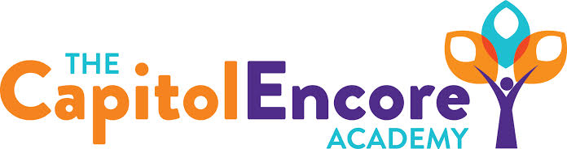

“Learning the Art of Success Every day!”

ENCORE BOARD OF DIRECTORS

Mission Statement
The Capitol Encore Academy will develop artists who inspire others with principles of design and artful thinking through the integration of academic excellence, virtuous character and disciplined artistry.
April 16, 2018 Meeting Minutes
5:15 PM

The Capitol Encore Academy
126 Hay Street
Fayetteville, NC 28301

Call to Order By: W. Hustwit At: 5:15pm

Roll Call R. Poole Absent

S. Barnard Present

J. Fiebig Present

W. Hustwit Present

S. Angarita Absent

U. Taylor Absent

M. Brand Present

A. Thornberg Absent

T. Hinds Present

Non Board Members A. Hill- Principal

Contributing J. Salisbury- School Nutrition

W. Kneer- Superintendent

Conflict of Interest Inquiry of any potential COI - None

Pledge of Allegiance

Approval of Agenda Motion by S. Barnard seconded by T. Hinds to approve the agenda.

Y-5 N-0

Motion Carries

Consent Items Motion by T. Hinds seconded by M. Brand to approve the minutes from the March 19, 2018 Regular Meeting.

Y-5 N-0

Motion Carries

Motion by J. Fiebig seconded by T. Hinds to approve March Financial Report.

Y-5 N-0

Motion Carries

Board Committee Curriculum Committee- Hill & Covington attended 2 sessions on new standards coming out, discussed standards changes in depth.

Family Educator Org FEO gave an update on finances, discussed upcoming events and discussed the Board’s thoughts on th number of fundraisers.

SIT Report Have held both large and smll group SIT meetings. Parents are becoming more involved in parent University. Continuing conversations surrounding indicators that are being worked on.

Admin Report Shared current and future enrollment, discipline data, teacher observations that have taken place throughout the month. Update on the Beginning Teacher program. Reviewed Teach Like a Champion training that administration took part in. We had better turn out at the Parent University, subject discussed were EOG, summer extension activities, Common Core Standards and learning differences. Staff attended the Campbell Job Fair and met some great candidates; NCSU job fair upcoming. Shared upcoming events.

Discussion Items Discussed the façade mural; call for artists proposals by the end of May, work to be performed June-July.

Discussed EOG Bootcamp: review data, what standards are on EOG, the assessments review these standards, students are grouped based on MTSS results.

Action Items None

Call to the Public None

Announcements The next Board of Director’s meeting will be held on May 21, 2018 5:15pm.

Adjournment Motion By: Seconded By: Time:

S. Barnard T. Hinds 6:06

