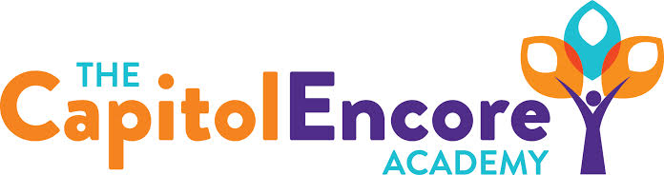

“Learning the Art of Success Every day!”

ENCORE BOARD OF DIRECTORS

Mission Statement
The Capitol Encore Academy will develop artists who inspire others with principles of design and artful thinking through the integration of academic excellence, virtuous character and disciplined artistry.
June 18, 2018 Meeting Minutes
5:15 PM

The Capitol Encore Academy
126 Hay Street
Fayetteville, NC 28301

Call to Order By: W. Hustwit At: 5:38pm

Roll Call R. Poole Present

S. Barnard Present 6:08

J. Fiebig Present

W. Hustwit Present

S. Angarita Absent

U. Taylor Present

M. Brand Present

A. Thornberg Absent

T. Hinds Present

Non Board Members A. Hill- Principal

Contributing J. Salisbury- School Nutrition

W. Kneer- Superintendent

Conflict of Interest Inquiry of any potential COI - None

Pledge of Allegiance

Approval of Agenda Motion by J. Poole seconded by U. Taylor to approve the agenda with amendments

Y-6 N-0

Motion Carries

Consent Items Motion by J. Poole seconded by U. Taylor to approve the minutes from the May 21, 2018 Regular Meeting.

Y-6 N-0

Motion Carries

Motion by U. Taylor seconded by J. Poole to approve May Financial Report.

Y-6 N-0

Motion Carries

Board Committee Curriculum Committee- M. Brand discussed a free PD in Wilkes County for Singapore Math that A. Hill will be attending in July.

School Nutrition Committee- Application for FY19 approved by State.

Family Educator Org Preseident stepped down, discussing election for replacement.

SIT Report Presented feedback from work conditions survey. Had 100% participation, results looked good, improvement upon prior year results. Discussed upcoming school year, who will return and what continued efforts there will be to engage parents.

Admin Report Discussed current/future enrollment data going into summer. Discussed discipline data from the previous Board Meeting. Presented final BT report and results of program. Discussed mentors for next year and the associated stipends. Presented the upcoming new family cookout and starting traditions. Presented hiring update, including (3) existing open positions. Shared preliminary data for EOG scores as well as growth data from IReady scores. Discussed the 3 misadministrations from EOGs.

Discussion Items Board Vacancy- S. Barnard is stepping down due to relocation. Board thanked him for his service.

Budget amendment- Discussed the final amendment to the FY18 budget.

Upcoming Board Dates- Next Board meeting will be held on August 20th at 5:15.

New Hires- Discussed proposed new hires that were recommended for the upcoming school year.

Action Items Motion by J. Poole, seconded by U. Taylor to adopt the FY19 Budget as presented in the Budget Hearing.

Y- 7 N- 0

Motion Carries

Motion by U. Taylor, seconded by J. Poole to amend the FY18 budget as presented.

Y – 7 N – 0

Motion Carries

Motion by T. Hinds, seconded by M. Brand to approve the New Hires as presented.

Y – 7 N – 0

Motion Carries

Motion by T. Hinds, seconded by M. Brand on approval of August Board Meeting Date.

Y – 7 N – 0

Motion Carries

Motion by J. Poole, seconded by U. Taylor to accept resignation of S. Barnard.

Y – 7 N – 0

Motion Carries

Call to the Public Staff member discussed the successful arts and integration nights held. Praised the dance recital by E. Norris. Complimented the work T. Brownlee and K. Haslem did on their aquatic artwork projects.

S. Barnard thanked the Board and School admin for an amazing journey, commented that this project is one of the most rewarding of his career in education.

Announcements The next Board of Director’s meeting will be held on August 20, 2018 5:15pm.

Adjournment Motion By: Seconded By: Time:

T. Hinds U. Taylor 6:26

