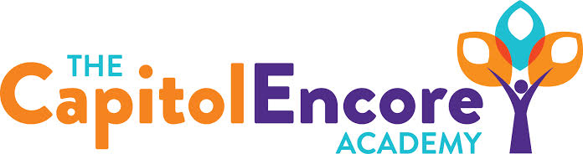

“Learning the Art of Success Every day!”

ENCORE BOARD OF DIRECTORS

Mission Statement
The Capitol Encore Academy will develop artists who inspire others with principles of design and artful thinking through the integration of academic excellence, virtuous character and disciplined artistry.
January 28th, 2019 Meeting Minutes
5:15 PM

The Capitol Encore Academy
126 Hay Street
Fayetteville, NC 28301

Call to Order By: W. Hustwit At: 5:15pm

Roll Call R. Poole Absent

J. Fiebig Present

W. Hustwit Present

S. Angarita Present

U. Taylor Present

A. Thornberg Absent

T. Hinds Present-5:40

Non Board Members A. Hill- Principal

Contributing J. Salisbury- School Nutrition

Conflict of Interest Inquiry of any potential COI - None

Pledge of Allegiance

Approval of Agenda Motion by U. Taylor seconded by W. Hustwit to approve the agenda with amendments

Y-4 N-0

Motion Carries

Consent Items Motion by W. Hustwit seconded by U. Taylor to approve the minutes from the December 17, 2018 Regular Meeting.

Y-4 N-0

Motion Carries

Motion by W. Hustwit seconded by U. Taylor to approve the December financial report.

Y-4 N-0

Motion Carries

Board Committee School Nutrition Report- Discussed the Donor’s Choose that was funded and the launching of the T3 Culinary class. Waiting on grant results from a double oven.

FEO Report Mrs. Hill is meeting with the chair tomorrow to discuss the vision of the FEO and heading more towards volunteering time instead of fundraising.

SIT Report Discussed grade level newsletters via dojo going home weekly. This gives parents one line of cummunication instead of many.

Administrative Report Open enrollment for 19-20 has begun, with the lottery scheduled for March 13th. Discipline update shpwing top offenses and days of OSS. Presented Summer School plan choices and open enrollment events. Discussed upcoming events.

Discussion Items Charter Contract Renewal- Discussed the CSAB indicating a renewal term of 5 years.

Building Update- HRC meeting went well, project was approved. Asbestos abatement has been completed. An independent air quality test was conducted, results showed no contaminates. Moving forward with demolition.

Change of April Board meeting was discussed and agreed upon, but no action taken.

Action Items None

Call to the Public Staff member spoke about the drumline class. First outdoor performance will be on February 22.

Announcements The next Board of Director’s meeting will be held on Febraury 25, 2019 5:15pm.

Adjournment Motion By: Seconded By: Time:

T. Hinds W. Hustwit 6:03

Y – 5 N – 0

Motion carries

