GET FREE
Chemistry Kit
W/Paid Registration
EXPIRES 3/8/19

GIRLS PURSUING SCIENCE
BEAUTY OF STEM SERIES-BOSS
AFTER-SCHOOL STUDIO

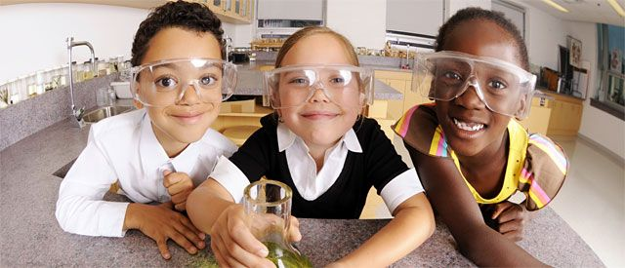

TUESDAYS: MAR 12TH- APR 16TH - 3:30 PM-4:30 PM

CAPITOL ENCORE ACADEMY -GRADES 2ND – 8TH

WEEKLY STEAM ACTIVITIES

A DIFFERENT PROJECT EACH WEEK

$145 – Includes all Product Supplies & Materials!

Learn the Chemistry behind Bath Bombs, Lip Balm, Bubble Bath, Lotion, Soap Jellies, Package Design, Marketing, Adverting, and much more!

REGISTER Online before 3/8/19 and get a FREE BOSS Kit! (while supplies last)
Project based learning activities that engage girls in fun innovative lessons in cosmetic chemistry!
Create, Design, Make, and Take it Home!
It’s the Beauty of Science

REGISTER NOW! WWW.KIDSNTECHNOLOGY.NET
TEXT YOUR QUESTIONS TO: 901.335.5690
CALL: 704-469-3535
EMAIL: info@kidsntehnology.net

