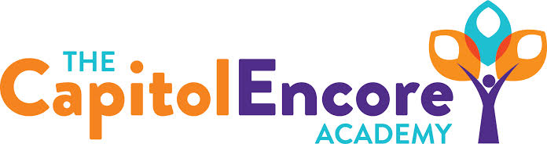

“Learning the Art of Success Every day!”

ENCORE BOARD OF DIRECTORS

Mission Statement
The Capitol Encore Academy will develop artists who inspire others with principles of design and artful thinking through the integration of academic excellence, virtuous character and disciplined artistry.
April 8, 2019 Meeting Minutes
5:15 PM

Location – The Capitol Encore Academy
126 Hay Street
Fayetteville, NC 28301

Call to Order By: W. Hustwit At: 5:15PM

Roll Call R. Poole Absent

J. Fiebig Present

W. Hustwit Present

U. Taylor Present

S. Angarita Present – 5:28pm

A. Thornberg Absent

T. Hinds Present

Non Board Members A. Hill- Principal

Contributing J. Salisbury- School Nutrition

W. Kneer- Superintendent

Conflict of Interest Inquiry of any potentail COI - None

Pledge of Allegiance

Approval of Agenda Motion by U. Taylor, seconded by W. Hustwit to approve the agenda

Y-5 N-0

Motion Carries

Consent Items Motion by U. Taylor, seconded by T. Hinds to approve the minutes from March 25, 2019.

Y-5 N-0

Motion Carries

Motion by U. Taylor, seconded by W. Hustwit to approve the March Financial Report

Y-5 N-0

Motion Carries

Board Committee NONE

FEO Report The FEO is working with the Holiday Inn on I95 to plan a middle school dance for the last day of school, running from 7pm-10pm. Currently 4-5 adults willing to volunteer their time.

SIT Report SIT continues to work on the indicators for this current school year. Mrs. Majka reminded staff that their work on these is due in writing to her. Also, the 3rd Trimester Parent University may be cancelled due to lack of interest. However, SIT will still post the videos from the choices this trimester.

Administrative Report Enrollment shows 411 students re-enrolled, with 99 of the new students accepting their space.

Presented monthly discipline

Discussed the NCDPI surpise visit from April 2nd, including the GLOWs and GROWs

Gave the final number from the giving drive in February, which was close to $4,000

Discussed needs for EOG testing, along with dates

Discussion Items Discussed the hypotheticals for entering into a bond agreement with HJ Sims, including the costs, and benefits, for the school. Discussed profits for using this method as well as likelihood for alternate funding

Talked to Office of Charter Schools regarding the school calendar, asking to mirror this year’s calendar, which is allowed.

Discussed staggered start for Kindergarten for the 19-20 school year. This would benefit both students and staff members, giving smaller groups a chance to adjust first.

Received the 5 Year Charter Agreement and will be signing and getting it notorized

Action Items Motion by J. Fiebig, seconded by U. Taylor to enter into agreement with HJ Sims

Y-5 N-0

Motion Carries

Call to the Public NONE

Announcements The next Board of Director’s meeting will be held on May 20, 2019 at 5:15 pm.

Adjournment Motion By: U. Taylor Seconded By: J. Fiebig Time: 6:01pm

Y-5 N-0

Motion Carries

