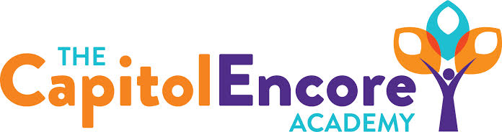

“Learning the Art of Success Every day!”

ENCORE BOARD OF DIRECTORS

Mission Statement
The Capitol Encore Academy will develop artists who inspire others with principles of design and artful thinking through the integration of academic excellence, virtuous character and disciplined artistry.
March 18th, 2019 Meeting Minutes
5:15 PM

The Capitol Encore Academy
126 Hay Street
Fayetteville, NC 28301

Call to Order By: W. Hustwit At: 5:15pm

Roll Call R. Poole Present

J. Fiebig Present

W. Hustwit Present

S. Angarita Present 5:31

U. Taylor Present 5:29

A. Thornberg Absent

T. Hinds Present

Non Board Members A. Hill- Principal

Contributing J. Salisbury- School Nutrition

W. Kneer- Superintendent

Conflict of Interest Inquiry of any potential COI - None

Pledge of Allegiance

Approval of Agenda Motion by W. Hustwit seconded by J. Fiebig to approve the agenda with amendments

Y-4 N-0

Motion Carries

Consent Items Motion by J. Poole seconded by W. Hustwit to approve the minutes from the February 25, 2019 Regular Meeting.

Y-4 N-0

Motion Carries

Motion by J. Poole seconded by W. Hustwit to approve the February financial report.

Y-4 N-0

Motion Carries

Board Committee School nutrition report- NC requires new policy for allergy plan. By April we should hear back on the double oven grant.

FEO Report None

SIT Report Evidence for Parent Involvement Indicator shown through Facebook poll which reveals primary parent satisfaction.

Administrative Report Enrollment update shows 411 students re-enrolled.

Recruitment/Retention events including Spring Open House, Night at the Woodpeckers Stadium, Summer Cookout, monthly newletters and school tours.

Presented discipline referrals for the month.

Discussed EOG preparations including EOG bootcamp.

Intent to return for staff shows that only 1 plans on not returning

TCEA job fair 4-8-19

Discussion Items Pittman building update- demo has been completed, construction has began. Timeline will be close, but will be ready for the start of school. Construction costs will either be rolled into lease, or into bond purchase on current site.

Renewal update- SBE approved renewal through June 30, 2024

HJ Sims Introduction- Jay Hromatka from HJ Sims presented to the Board, explained the bond process and potential terms.

Action Items Motion to approve the Safe Allergy Environment Plan by J. Poole, supported by S. Angarita.

Y – 6 N – 0

Motion carries

Call to the Public Parent has concerns regarding EC student who has returned to regularly scheduled classes, coming off of FAPE services being provided from home. Returning student had altercations with her son, which were deemed by a court to qualify as assult.

Announcements The next Board of Director’s meeting will be held on April 8th, 2019 5:15pm.

Adjournment Motion By: Seconded By: Time:

U. Taylor W. Hustwit 6:04

Y – 6 N – 0

Motion carries

