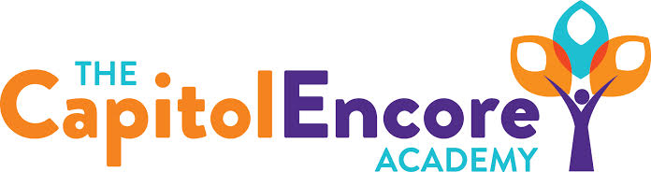

“Learning the Art of Success Every day!”

ENCORE BOARD OF DIRECTORS

Mission Statement
The Capitol Encore Academy will develop artists who inspire others with principles of design and artful thinking through the integration of academic excellence, virtuous character and disciplined artistry.
September 16, 2019 Meeting Minutes
5:15 PM

Location – The Capitol Encore Academy
126 Hay Street
Fayetteville, NC 28301

Call to Order By: J. Fiebig At: 5:15PM

Roll Call R. Poole Present

J. Fiebig Present

W. Hustwit Present

U. Taylor Absent

S. Angarita Present

T. Hinds Absent

Non Board Members T. Canteen- Principal

Contributing J. Salisbury- School Nutrition

W. Kneer- Superintendent

Conflict of Interest Inquiry of any potentail COI - None

Pledge of Allegiance

Approval of Agenda Motion by J. Poole, seconded by W. Hustwit to approve the agenda with amendments

Y-4 N-0

Motion Carries

Consent Items Motion by J. Poole, seconded by W. Hustwit to approve the minutes from the August 19, 2019 Regular Meeting.

Y-4 N-0

Motion Carries

Motion by J. Poole, seconded by W. Hustwit to approve the August Financial Report

Y-4 N-0

Motion Carries

Board Committee School Nutrition Report- The double oven has come in, ordered a 2nd freezer. D. Akers hopes to be back in state by the end of the month.

FEO Report None

SIT Report SIT member names, meeting dates and indicators presented.

Administrative Report Gave update on SIT progress as well as introduced the Staff Member of the Month. Discussed School Performance Grade, acheivement, growth & proficiency scores and changes and initiatives put in place to address needs. Provided discipline data, PLC schedule and movement towards an AIG program. Administration introduced Student Council to the Board. Presented the idea of Chameleon Corner Character Academy and the impact it could have on delivery of instruction.

Discussion Items Had further discussion on the Letter Grade/EOG results and the plan in place. Discussed attendance, EC population and needs and the needs of new incoming students/the effect these groups have on our overall performance. Bond update with discussion on the upcoming closing.

Action Items None

Call to the Public None

Announcements The next Board of Director’s meeting will be held on October 21, 2019 at 5:15 pm.

Adjournment Motion By: W. Hustwit supported By: J. Poole Time: 6:05pm

Y-4 N-0

Motion Carries

