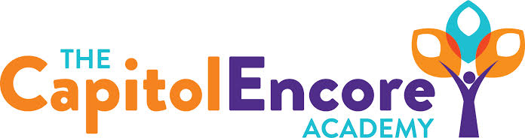

“Learning the Art of Success Every day!”

ENCORE BOARD OF DIRECTORS

Mission Statement
The Capitol Encore Academy will develop artists who inspire others with principles of design and artful thinking through the integration of academic excellence, virtuous character and disciplined artistry.

December 16, 2019 Meeting Minutes
5:15 PM

Location – The Capitol Encore Academy
126 Hay Street
Fayetteville, NC 28301

Call to Order By: J. Fiebig At: 5:15PM

Roll Call R. Poole Present

J. Fiebig Present

W. Hustwit Present

U. Taylor Absent

S. Angarita Present

T. Hinds Absent

Non Board Members T. Canteen- Principal

Contributing J. Salisbury- School Nutrition

W. Kneer- Superintendent

Conflict of Interest Inquiry of any potentail COI - None

Pledge of Allegiance

Approval of Agenda Motion by J. Poole, seconded by W. Hustwit to approve the agenda as presented.

Y-4 N-0

Motion Carries

Consent Items Motion by J. Fiebig, seconded by W. Hustwit to approve the minutes from the November 18, 2019 Regular Meeting.

Y-4 N-0

Motion Carries

Motion by J. Poole, seconded by W. Hustwit to approve the November Financial Report

Y-4 N-0

Motion Carries

Board Committee Discussed the school nutrition equipment grant and the re-bid of food service contract this summer. Informed Board of next year’s 5 year administrative review.

Student Council Student Council President presented multiple ideas

Report including: 1) Collaborating with builders club to run a Valentine’s dance for middle school. 2) Adjusting the zone levels for middle school lunch. Proposing 25 minutes of Zone 1, 5 minutes of zone 2, then zone 0 for dismissal. Also wish to upgrade the PBIS prizes for lunch. 3) Dress code- allow them to wear jackets/hoodies on Friday’s that aren’t at TCEA. They will present an official proposal in January.

Administrative Report Majka named Incredible of the Month. Discussed the hire of Carson for 3rd grade and McKoy for 1st grade. NC Check in- Completing one in January to measure proficiency for grade level standards. Will do another in March to prepare for EOG. DPI will review AIG plan in January. March 26th all charters invited to TCEA to learn more about Arts Integration and A+.

Board Discussion Board will revisit the Donor Policy in January to potentially adopt updated version. Discussed changing the February Board Meeting date to Feb 3rd.

Action Items Motion by W. Hustwit, supported by J. Poole to approve new hires as presented.

Y – 4 N – 0

Motion carries

Motion by J. Fiebig, supported by J. Poole to move February Board Meeting to February 3rd.

Call to the Public None

Announcements The next Board of Director’s meeting will be held on January 13, 2020 at 5:15 pm.

Adjournment Motion to adjourn by J. Poole, supported by W. Hustwit Time: 5:55pm

Y-4 N-0

Motion Carries

