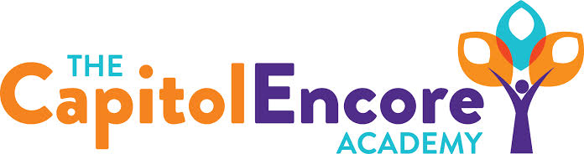

“Learning the Art of Success Every day!”

ENCORE BOARD OF DIRECTORS

Mission Statement
The Capitol Encore Academy will develop artists who inspire others with principles of design and artful thinking through the integration of academic excellence, virtuous character and disciplined artistry.

March 16, 2020 Meeting Minutes
5:15 PM

Location – The Capitol Encore Academy
126 Hay Street
Fayetteville, NC 28301

Call to Order By: W. Hustwit At: 5:15PM

Roll Call R. Poole Present

J. Fiebig Present

W. Hustwit Present

U. Taylor Present

S. Angarita Absent

T. Hinds Absent

Non Board Members T. Canteen- Principal

Contributing J. Salisbury- School Nutrition

W. Kneer- Superintendent

Conflict of Interest Inquiry of any potentail COI - None

Pledge of Allegiance

Approval of Agenda Motion by U. Taylor, seconded by J. Poole to approve the agenda as presented.

Y-4 N-0

Motion Carries

Consent Items Motion by J. Poole, seconded by J. Fiebig to approve the minutes from the January 13, 2020 Regular Meeting.

Y-4 N-0

Motion Carries

Motion by U. Taylor , seconded by J. Poole to approve the January/February Financial Report

Y-4 N-0

Motion Carries

Board Committee School Nutrition- Everything is prepared, we can serve meel to any school age child. We served 101 on the first day and are serving food 2 days per week.

Student Council None

Report

Administrative Report Incredible of the month is Ms. Covington. Continuation of Learning- Roll out plan has gone smoothly thus far. EC participation is a little low, Ms. Coker has been reaching out to families. Will continue to improve and refine our COL moving forward. Presented and proposed school calendar for 20/21 school year. Presented potential new hires for Middle School.

Board Discussion Preparing for what is to come and the potential for closing the remainder of the school year.

Action Items Motion by J. Fiebig, supported by J. Poole to adopt the 20/21 school calendar as presented.

Y – 4 N – 0

Motion carries

Motion by J. Fiebig, supported by W. Hustwit to approve the new hires as presented.

Y – 4 N – 0

Motion carries

Call to the Public None

Announcements The next Board of Director’s meeting will be held on April 20, 2020 at 5:15 pm.

Adjournment Motion to adjourn by U. Taylor, supported by W. Hustwit Time: 5:55pm

Y-4 N-0

Motion Carries

