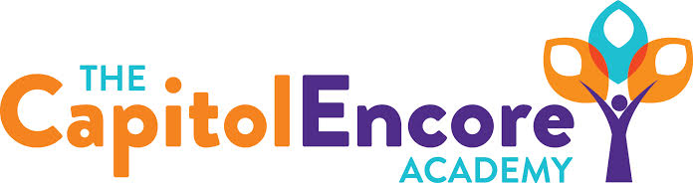

“Learning the Art of Success Every day!”

ENCORE BOARD OF DIRECTORS

Mission Statement
The Capitol Encore Academy will develop artists who inspire others with principles of design and artful thinking through the integration of academic excellence, virtuous character and disciplined artistry.

June 29, 2020 Meeting Minutes
5:15 PM

Location – The Capitol Encore Academy
126 Hay Street
Fayetteville, NC 28301

Call to Order By: W. Hustwit At: 5:34PM

Roll Call R. Poole Present

J. Fiebig Present

W. Hustwit Present 5:40

U. Taylor Present

S. Angarita Absent

T. Hinds Present

Non Board Members T. Canteen- Principal

Contributing J. Salisbury- School Nutrition

W. Kneer- Superintendent

Conflict of Interest Inquiry of any potentail COI - None

Pledge of Allegiance

Approval of Agenda Motion by U. Taylor, seconded by T. Hinds to approve the agenda as presented.

Y-4 N-0

Motion Carries

Consent Items Motion by J. Poole, seconded by J. Fiebig to approve the minutes from the May 18, 2020 Regular Meeting.

Y-4 N-0

Motion Carries

Motion by U. Taylor, seconded by T. Hinds to approve the May Financial Report

Y-4 N-0

Motion Carries

Board Committee School Nutrition- Summer feeding numbers slighly down due to construction. Summer feeding audit went well.

Student Council None

Report

Administrative Report Admin presented “Year in Review”

Discussed additional smartboard needs

Presented proposed new hires

Discussed Jumpstart summer program

Presented Teacher Survey Working Conditions

Discussed Uniform Policy revisions & potential A/B schedule

Board Discussion Discussion surrounding possible scenarios for start of FY21 school year.

Discussed FY20 Amendments

Action Items Motion by J. Fiebig, supported by W. Hustwit to approve new hires as presented.

Y – 5 N – 0

Motion carries

Motion by U. Taylor, supported by J. Fiebig to amend FY20 Budget as presented.

Y – 5 N – 0

Motion carries

Motion by U. Taylor, supported by W. Hustwit to adopt FY21 Budget as presented in Budget Hearing.

Y-5 N-0

Motion carries

Call to the Public None

Announcements The next Board of Director’s meeting will be held on July 20, 2020 at 5:15 pm.

Adjournment Motion to adjourn by W. Hustwit, supported by J. Fiebig Time: 6:26pm

Y-5 N-0

Motion Carries

