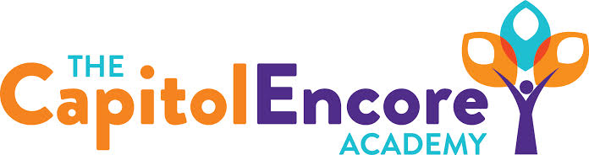

“Learning the Art of Success Every day!”

ENCORE BOARD OF DIRECTORS

Mission Statement
The Capitol Encore Academy will develop artists who inspire others with principles of design and artful thinking through the integration of academic excellence, virtuous character and disciplined artistry.

July 20, 2020 Meeting Minutes
5:15 PM

Location – The Capitol Encore Academy
126 Hay Street
Fayetteville, NC 28301

Call to Order By: J. Fiebig At: 5:16PM

Roll Call R. Poole Present

J. Fiebig Present

W. Hustwit Present

U. Taylor Absent

S. Angarita Present

T. Hinds Absent

Non Board Members T. Canteen- Principal

Contributing J. Salisbury- School Nutrition

W. Kneer- Superintendent

Conflict of Interest Inquiry of any potentail COI - None

Pledge of Allegiance

Approval of Agenda Motion by W. Hustwit, seconded by J. Fiebig to approve the agenda with amendments.

Y-4 N-0

Motion Carries

Consent Items Motion by W. Hustwit, seconded by J. Fiebig to approve the minutes from the June 29, 2020 Regular Meeting.

Y-4 N-0

Motion Carries

Motion by J. Fiebig, seconded by W. Hustwit to approve the minutes from the June 29, 2020 Budget Hearing.

Y-4 N-0

Motion by J. Fiebig, seconded by S. Angarita to approve the June Financial Report

Y-4 N-0

Motion Carries

Board Committee School Nutrition- Presented Web Based School Nutrition Application for Board consideration.

Administrative Report Discussed potential saftey concerns and solutions for arrival, dismissal, lunch and sick students.

Board Discussion Discussion surrounding possible scenarios for start of FY21 school year including virtual, AB schedule & full return. Board discussion surrounding the idea of remaining fluid and flexible in the decision to return to school, will wait as long as possible to make final decision on return to guage current climate, saftey concerns, parent feedback and potential liability. Communication with parents regarding this stance will begin next week and will continue on a weekly basis until a final decision is made. Discussion to appoint a School Safety Committee to meet on a weekly basis starting Aug 3 to discuss how things are trending and provide input on direction to take. The overall points are to make student and family safety the top priority and to provide a robust education under whichever format is taken.

Action Items Motion by W. Hustwit, supported by J. Fiebig to approve Web based School Nutrition application.

Y – 4 N – 0

Motion carries

Motion by W. Hustwit, supported by J. Poole to form a Return to School Safety Committee.

Y – 4 N – 0

Motion carries

Motion by J. Poole, supported by S. Angarita to add 5 Remote Instuctinal Days.

Y-4 N-0

Motion carries

Call to the Public Staff member expressed about the arts and how to adapt our offering if virtual.

Announcements The next Board of Director’s meeting will be held on August 17, 2020 at 5:15 pm.

Adjournment Motion to adjourn by S. Angarita, supported by J. Poole Time: 6:21pm

Y-4 N-0

Motion Carries

