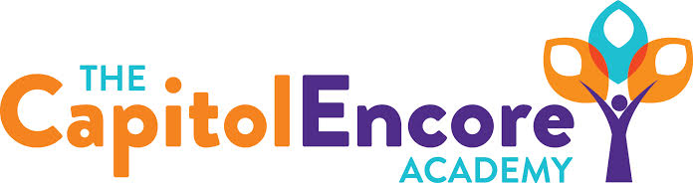

“Learning the Art of Success Every day!”

ENCORE BOARD OF DIRECTORS

Mission Statement
The Capitol Encore Academy will develop artists who inspire others with principles of design and artful thinking through the integration of academic excellence, virtuous character and disciplined artistry.

August 12, 2020 Meeting Minutes
5:15 PM

Location – The Capitol Encore Academy
126 Hay Street
Fayetteville, NC 28301

Call to Order By: J. Fiebig At: 5:15PM

Roll Call R. Poole Present

J. Fiebig Present

W. Hustwit Present

U. Taylor Present

S. Angarita Present

T. Hinds Absent

Non Board Members G. Falls- Director

Contributing J. Salisbury- School Nutrition

W. Kneer- Superintendent

Conflict of Interest Inquiry of any potentail COI - None

Pledge of Allegiance

Approval of Agenda Motion by J. Fiebig, seconded by U. Taylor to approve the agenda with amendments.

Y-5 N-0

Motion Carries

Consent Items Motion by J. Fiebig, seconded by W. Hustwit to approve the minutes from the July 20, 2020 Regular Meeting.

Y-5 N-0

Motion Carries

Motion by J. Fiebig, seconded by J. Poole to approve the July Financial Report

Y-5 N-0

Motion Carries

Board Committee Safe return committee discussed concerns with staff work overload, imune compromised families and staff, how to handle a positid COVID test and the logistics of arrival/dismissal and safely operating through a school day.

Administrative Report Discussed potential saftey concerns and solutions for arrival, dismissal, lunch and sick students.

Board Discussion Discussion surrounding potential scenarios for a safe start to school. Concerns centered around staff safety and workload, risk to students extended family and lack of experience in this environment. Idea was proposed that we allow a small controlled group of students in the building to receive their virtual education on site. This woud allow families in need with a face to face option and give the school a small group of students to perfect procedures and protocols with. This program offering is labeled Virtual Plus.

Proposed FY21 Board meeting dates;

9/23, 10/12, 11/9, 12/14, 1/25, 2/22, 3/8, 4/12, 5/10 & 6/14.

Action Items Motion by J. Fiebig, supported by W. Hustwit to approve FY21 Board Meeting dates.

Y – 5 N – 0

Motion carries

Motion by W. Hustwit, supported by S. Angarita to return to school in a virtual format, under Plan C.

Y – 4 N – 1

Motion carries

Call to the Public None

Announcements The next Board of Director’s meeting will be held on September 23, 2020 at 5:15 pm.

Adjournment Motion to adjourn by J. Poole, supported by W. Hustwit Time: 6:24pm

Y-5 N-0

Motion Carries

