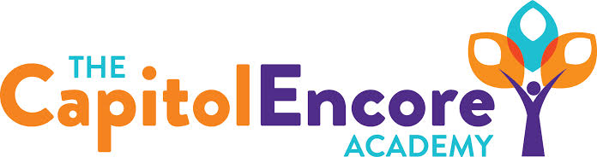

“Learning the Art of Success Every day!”

ENCORE BOARD OF DIRECTORS

Mission Statement
The Capitol Encore Academy will develop artists who inspire others with principles of design and artful thinking through the integration of academic excellence, virtuous character and disciplined artistry.

September 23, 2020 Meeting Minutes
5:15 PM

Location – The Capitol Encore Academy
126 Hay Street
Fayetteville, NC 28301

Call to Order By: J. Fiebig At: 5:15PM

Roll Call R. Poole Present

J. Fiebig Present

W. Hustwit Present

U. Taylor Present

S. Angarita Present

T. Hinds Present

Non Board Members G. Falls- Director

Contributing J. Salisbury- School Nutrition

W. Kneer- Superintendent

Conflict of Interest Inquiry of any potentail COI - None

Pledge of Allegiance

Approval of Agenda Motion by J. Fiebig, seconded by W. Hustwit to approve the agenda with amendments.

Y-6 N-0

Motion Carries

Consent Items Motion by J. Fiebig, seconded by U. Taylor to approve the minutes from the August 17, 2020 Regular Meeting.

Y-6 N-0

Motion Carries

Motion by U. Taylor, seconded by S. Angarita to approve the August Financial Report

Y-6 N-0

Motion Carries

Board Committee None

Administrative Report Discussed instructional staff changes

Shared results of Teacher Survey

Provided Virtual Plus Update

Board Discussion Discussion surrounding K-2 returning face to face. Presented to the Board how Virtual Plus has been running, some of the procedures that we have refined in order to sservice those students and how we plan to implement those across a greater scope. Concerns were discussed surrounding achievement gaps and losing students to other institutions offering face to face. School Administration’s opinion is that we can operate safely in a return to face to face.

Discussed potentially extending the acceptance window to March 4th to provide opportunity to replace student loss.

Action Items Motion by U. Taylor, supported by J. Poole to have grades K-2 return for face to face instruction.

Y – 6 N – 0

Motion carries

Motion by J. Fiebig, supported by S. Angarita to extended the FY21 enrollment window until the end of trimester 2.

Y – 6 N – 0

Motion carries

Call to the Public None

Announcements The next Board of Director’s meeting will be held on October 12, 2020 at 5:15 pm.

Adjournment Motion to adjourn by T. Hinds, supported by J. Poole Time: 5:57pm

Y-6 N-0

Motion Carries

