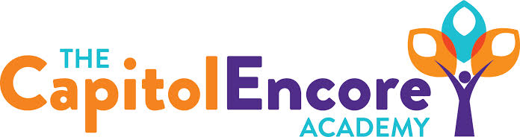

“Learning the Art of Success Every day!”

ENCORE ACADEMY BOARD OF DIRECTORS

Mission Statement
The Capitol Encore Academy will develop artists who inspire others with principles of design and artful thinking through the integration of academic excellence, virtuous character and disciplined artistry.
Agenda

Regular Meeting – November 9, 2020
5:15 PM

Location – The Capitol Encore Academy
126 Hay Street
Fayetteville, NC 28301

Call to Order By: At:

Roll Call R. Poole

J. Fiebig

W. Hustwit

U. Taylor

S. Angarita

T. Hinds

Conflict of Interest Inquiry of any potentail COI

Pledge of Allegiance

Approval of Agenda The Board will either approve the agenda as presented or amend the agenda with the approval of the Board.

Consent Items Approval of the minutes from the October 12, 2020 Regular Meeting.

(Attachment 1)

Approval of the October Financial Report. (Attachment 2)

Administration Report Updated on school related COVID concerns

Discussion Items FY20 Financial Audit

Plan moving forward

Action Itmes Motion to accept FY20 Financial Audit

Call to the Public The meeting is a meeting of the Board of Directors in public for the purpose of conducting the Academy’s business and is not considered a public community meeting. Those that wish to address the Board may do so at this time being recognized by the chair. Those that request to address the Board have a maximum of three minutes in which to speak.

Announcements The next Board of Director’s meeting will be held on December 14, 2020 at 5:15 pm.

Adjournment Motion By: Seconded By: Time:

