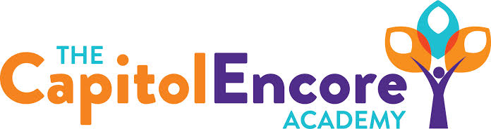

“Learning the Art of Success Every day!”

ENCORE BOARD OF DIRECTORS

Mission Statement
The Capitol Encore Academy will develop artists who inspire others with principles of design and artful thinking through the integration of academic excellence, virtuous character and disciplined artistry.
January 11, 2021 Meeting Minutes
5:15 pm

Location – The Capitol Encore Academy
126 Hay Street
Fayetteville, NC 28301

Call to Order By: J. Fiebig At: 5:15PM

Roll Call R. Poole - Present

J. Fiebig - Present

W. Hustwit - Present

U. Taylor - Absent

S. Angarita - Absent

T. Hinds - Present

Non Board Members Gerard Falls

Contributing Joe Salisbury

Will Kneer

Conflict of Interest Inquiry of any potentail COI – None

Pledge of Allegiance

Approval of Agenda Motion by J. Poole, seconded by W. Hustwit to approve the agenda with amendments.

Y-4 N-0

Motion carries

Consent Items Motion by W. Hustwit, seconded by T. Hinds to approve of the minutes from the December 14, 2020 Regular Meeting.

Y-4 N-0

Motion carries

Motion by J. Poole, seconded by T. Hinds to approve of the December Financial Report.

Y-4 N-0

Motion carries

Administration Report Update was given on the Health Department update for vaccine timing.

Brief update on virtual learning since return from Christmas break.

Virtual arts and ELA teachers have been identified

Discussion Items Discussion surrounding timing of a return to face to face instruction. The timing of Cumberland County’s return, vaccination schedule and safety of staff were all discussed. It was suggested that the School Safety Committee discuss options and the Board reconvene on Thursday, January 14th to make a decision.

Action Items Motion by J. Fiebig, supported by U. Taylor to hold a Special Board Meeting on January 14th at 5:15pm.

Y-4 N-0

Motion carries

Call to the Public The meeting is a meeting of the Board of Directors in public for the purpose of conducting the Academy’s business and is not considered a public community meeting. Those that wish to address the Board may do so at this time being recognized by the chair. Those that request to address the Board have a maximum of three minutes in which to speak.

Staff member asked if the Special Board Meeting would be open to the public. (The Board confirmed that it would be a public meeting).

Announcements The next Board of Director’s meeting will be held on January 14, 2021 at 5:15 pm.

Adjournment Motion By: U. Taylor Seconded By: W. Hustwit Time: 5:35PM

Y-4 N-0

Motion Carries

