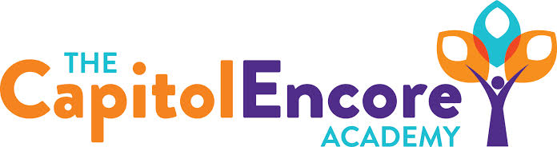

“Learning the Art of Success Every day!”

ENCORE BOARD OF DIRECTORS

Mission Statement
The Capitol Encore Academy will develop artists who inspire others with principles of design and artful thinking through the integration of academic excellence, virtuous character and disciplined artistry.
December 14, 2020 Meeting Minutes
5:15 pm

Location – The Capitol Encore Academy
126 Hay Street
Fayetteville, NC 28301

Call to Order By: J. Fiebig At: 5:15PM

Roll Call R. Poole - Absent

J. Fiebig - Present

W. Hustwit - Present

U. Taylor - Present – 5:17

S. Angarita - Present

T. Hinds - Present

Non Board Members Gerard Falls

Contributing Joe Salisbury

Will Kneer

Conflict of Interest Inquiry of any potentail COI – None

Pledge of Allegiance

Approval of Agenda Motion by J. Fiebig, seconded by S. Angarita to approve the agenda with amendments.

Y-5 N-0

Motion carries

Consent Items Motion by S. Angarita, seconded by W. Hustwit to approve of the minutes from the November 9, 2020 Regular Meeting.

Y-5 N-0

Motion carries

Motion by U. Taylor, seconded by T. Hinds to approve of the November Financial Report.

Y-5 N-0

Motion carries

Administration Report Discussion of the recommendations from the Safety Committee.

Presentation of the Beginning Teacher Support Plan & the 2021 Summer Plan.

Discussion surrounding the possibility of including 200 Mason St as a potential site for Middle School and future High School grades.

Discussion Items Discussion surrounding instructional format entering 2021. The idea was thrown out to mirror Cumberland County’s plan. Staff safety and security of staff and students is first priority in Board making return decision. Viability aand local health conditions will drive final decision on date.

Action Items Motion by U. Taylor, supported by W. Hustwit to approve BTSP.

Y-5 N-0

Motion carries

Motion by W. Hustwit, supported by T. Hinds to approve 2021 Summer Plan.

Y-5 N-0

Motion carries

Motion by J. Fiebig, supported by S. Angarita to change January Board Meeting to January 11th.

Y-5 N-0

Motion carries

Motion by J. Fiebig, supported by W. Hustwit to consider reopening January 19th pending a reccomendation from the Reopening Sub Committee.

Y-5 N-0

Motion carries

Call to the Public The meeting is a meeting of the Board of Directors in public for the purpose of conducting the Academy’s business and is not considered a public community meeting. Those that wish to address the Board may do so at this time being recognized by the chair. Those that request to address the Board have a maximum of three minutes in which to speak.

Staff member thanked the Board for their Christmas gifts and thoughtful consideratons throughout the pandemic.

Announcements The next Board of Director’s meeting will be held on January 11, 2021 at 5:15 pm.

Adjournment Motion By: W. Hustwit Seconded By: U. Taylor Time: 5:53PM

Y-5 N-0

Motion Carries

