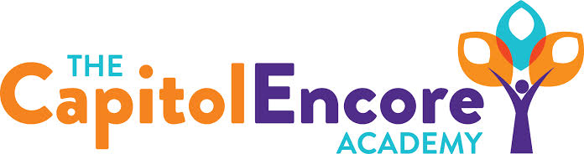

“Learning the Art of Success Every day!”

ENCORE BOARD OF DIRECTORS

Mission Statement
The Capitol Encore Academy will develop artists who inspire others with principles of design and artful thinking through the integration of academic excellence, virtuous character and disciplined artistry.
March 8, 2021 Meeting Minutes
5:15 pm

Location – The Capitol Encore Academy
126 Hay Street
Fayetteville, NC 28301

Call to Order By: J. Fiebig At: 5:15PM

Roll Call J. Poole - Present

J. Fiebig - Present

W. Hustwit - Present

U. Taylor - Absent

S. Angarita - Absent

T. Hinds - Present

Non Board Members Gerard Falls

Contributing Joe Salisbury

Will Kneer

Conflict of Interest Inquiry of any potential COI – None

Pledge of Allegiance

Approval of Agenda Motion by J. Fiebig, seconded by J. Poole to approve the agenda with amendments.

Y-4 N-0

Motion carries

Consent Items Motion by J. Fiebig, seconded by W. Hustwit to approve of the minutes from the February 22, 2021 Regular Meeting.

Y-4 N-0

Motion carries

Motion by J. Poole, seconded by T. Hinds to approve of the February Financial Report.

Y-4 N-0

Motion carries

Administration Report 2nd Trimester is complete, grades are due today. Completed staff intent to return forms, 45 out of 50 have indicated an intent to return. 5 year Title I Audit materials have been submitted, audit interviews are next week. Reenrollment responses from parents indicate only 9 families not returning next year.

Discussion Items Update on progress towards securing Mason St. location for MS/HS.

Grades 6-8 return next week on Plan B.

Action Items Motion to increase classroom capacity in grades K-5 to exhaust wait list and not to exceed 18 by W. Hustwit, supported by J. Fiebig.

Y-4 N-0

Motion carries

Call to the Public Parent inquiry on date for lifting cap.

Announcements The next Board of Director’s meeting will be held on April 12, 2021 at 5:15 pm.

Adjournment Motion By: W. Hustwit Seconded By: T. Hinds Time: 5:49PM

Y-4 N-0

Motion Carries

