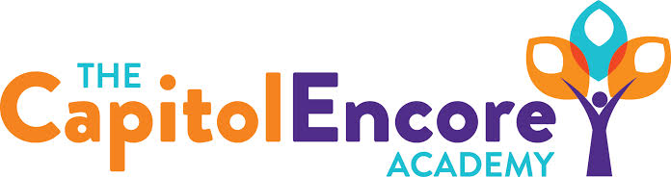

“Learning the Art of Success Every day!”

ENCORE BOARD OF DIRECTORS

Mission Statement
The Capitol Encore Academy will develop artists who inspire others with principles of design and artful thinking through the integration of academic excellence, virtuous character and disciplined artistry.
April 19, 2021 Meeting Minutes
5:15 pm

Location – The Capitol Encore Academy
126 Hay Street
Fayetteville, NC 28301

Call to Order By: J. Fiebig At: 5:15PM

Roll Call J. Poole - Present

J. Fiebig - Present

W. Hustwit - Present

U. Taylor - Present

S. Angarita - Absent

T. Hinds - Absent

Non Board Members Gerard Falls

Contributing Joe Salisbury

Will Kneer

Conflict of Interest Inquiry of any potential COI – None

Pledge of Allegiance

Approval of Agenda Motion by W. Hustwit, seconded by U. Taylor to approve the agenda with amendments.

Y-4 N-0

Motion carries

Consent Items Motion by J. Fiebig, seconded by J. Poole to approve of the minutes from the March 30, 2021 Special Board Meeting.

Y-4 N-0

Motion carries

Motion by J. Fiebig, seconded by W. Hustwit to approve of the March Financial Report.

Y-4 N-0

Motion carries

Administration Report Presented and discussed the proposed School Family Compact and the Family Engagement Policy.

Discussed Summer School options; proposing June 14-July 19, 5 days a week, 6 hours per day.

Discussed staffing plan and timing of offer letters.

Discussion Items Update on progress towards securing Mason St. location for MS/HS.

Action Items Motion to approve School Family Compact by W. Hustwit, supported by U. Taylor.

Y-4 N-0

Motion carries

Motion to adopt Family Engagement Policy by U. Taylor, supported by W. Hustwit.

Y-4 N-0

Motion Carries

Call to the Public None

Announcements The next Board of Director’s meeting will be held on May 10, 2021 at 5:15 pm.

Adjournment Motion By: W. Hustwit Seconded By: J. Poole Time: 5:41PM

Y-4 N-0

Motion Carries

