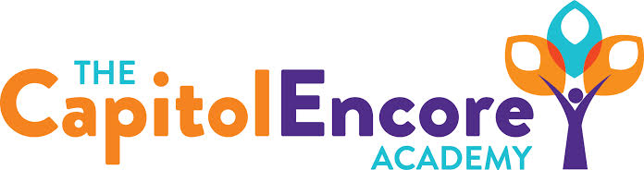

“Learning the Art of Success Every day!”

ENCORE BOARD OF DIRECTORS

Mission Statement
The Capitol Encore Academy will develop artists who inspire others with principles of design and artful thinking through the integration of academic excellence, virtuous character and disciplined artistry.
March 30, 2021 Special Meeting Minutes
5:15 pm

Location – The Capitol Encore Academy
126 Hay Street
Fayetteville, NC 28301

Call to Order By: J. Fiebig At: 5:00PM

Roll Call J. Poole - Present

J. Fiebig - Present

W. Hustwit - Absent

U. Taylor - Present

S. Angarita - Absent

T. Hinds - Present

Non Board Members Gerard Falls

Contributing Joe Salisbury

Will Kneer

Conflict of Interest Inquiry of any potential COI – None

Pledge of Allegiance

Approval of Agenda Motion by J. Fiebig, seconded by T. Hinds to approve the agenda with amendments.

Y-4 N-0

Motion carries

Consent Items Motion by T. Hinds, seconded by J. Poole to approve of the minutes from the March 8, 2021 Regular Meeting.

Y-4 N-0

Motion carries

Discussion Items Presented School Calendar for FY22. Discussed the specifics of returning grades 6-8 under Plan A. Presented the Reimbursement Resolution for the proposed bond deal. Discussed having a Board representative for bond discussions and calls.

Action Items Motion to adopt FY22 school calendar as presented by J. Fiebig, supported by T. Hinds.

Y-4 N-0

Motion carries

Motion for grades 6-8 to return to face to face under Plan A by T. Hinds, supported by J. Fiebig.

Y-4 N-0

Motion carries

Motion to adopt Reimbursement Resolution by J. Poole, supported by T. Hinds.

Y-4 N-0

Motion carries

Motion to appoint J. Poole as Board Representative in Bond dealings by J. Fiebig, supported by T. Hinds.

Y-4 N-0

Motion carries

Call to the Public None

Announcements The next Board of Director’s meeting will be held on April 19, 2021 at 5:15 pm.

Adjournment Motion By: J. Poole Seconded By: T. Hinds Time: 5:20PM

Y-4 N-0

Motion Carries

