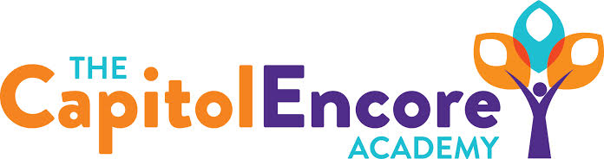

“Learning the Art of Success Every day!”

ENCORE BOARD OF DIRECTORS

Mission Statement
The Capitol Encore Academy will develop artists who inspire others with principles of design and artful thinking through the integration of academic excellence, virtuous character and disciplined artistry.
June 14, 2021 Budget Hearing Minutes Minutes
5:15 PM

The Capitol Encore Academy
126 Hay Street
Fayetteville, NC 28301

Call to Order By: J. Fiebig At: 5:15pm

Roll Call R. Poole Present

J. Fiebig Present

W. Hustwit Present

U. Taylor Present

T. Hinds Present

Conflict of Interest Inquiry of any potential COI - None

Pledge of Allegiance

Approval of Agenda Motion by J. Poole seconded by W. Hustwit to approve the agenda as presented.

Y-5 N-0

Motion Carries

Discussion Items Presented the proposed FY22 budget. Discussed funding, expenses, how budget supports areas of need.

Call to the Public None

Adjournment Motion By: Seconded By: Time:

W. Hustwit J. Poole 5:24

