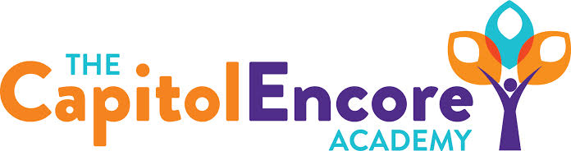

“Learning the Art of Success Every day!”

ENCORE BOARD OF DIRECTORS

Mission Statement
The Capitol Encore Academy will develop artists who inspire others with principles of design and artful thinking through the integration of academic excellence, virtuous character and disciplined artistry.
May 10, 2021 Meeting Minutes
5:15 pm

Location – The Capitol Encore Academy
126 Hay Street
Fayetteville, NC 28301

Call to Order By: J. Fiebig At: 5:15PM

Roll Call J. Poole - Present

J. Fiebig - Present

W. Hustwit - Present

U. Taylor - Present

S. Angarita - Absent

T. Hinds - Present 5:20

Non Board Members Gerard Falls

Contributing Joe Salisbury

Will Kneer

Conflict of Interest Inquiry of any potential COI – None

Pledge of Allegiance

Approval of Agenda Motion by J. Fiebig, seconded by U. Taylor to approve the agenda with amendments.

Y-4 N-0

Motion carries

Consent Items Motion by J. Fiebig, seconded by W. Hustwit to approve of the minutes from the April 19, 2021 Regular Board Meeting.

Y-4 N-0

Motion carries

Motion by J. Poole, seconded by W. Taylor to approve of the April Financial Report.

Y-4 N-0

Motion carries

Administration Report Presented hiring needs & progress towards filling those positions. Gave Summer School update with mapped out schedules & activities. Polled parents for feedback.

Gave enrollment update and plan for recruiting students in grades with openings.

Discussion Items Mason Street update, looking to close on bonds in early July, renovation to start immediately, construction in late August.

S. Angarita is resigning from the Board due to time constraints and other commitments.

Action Items Motion to accept S. Angarita’s resignation by U. Taylor, supported by T. Hinds..

Y-4 N-0

Motion carries

Call to the Public None

Announcements The next Board of Director’s meeting will be held on June 14, 2021 at 5:15 pm.

Adjournment Motion By: W. Hustwit Seconded By: J. Poole Time: 5:40PM

Y-4 N-0

Motion Carries

