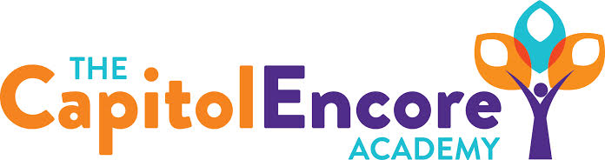

“Learning the Art of Success Every day!”

ENCORE BOARD OF DIRECTORS

Mission Statement
The Capitol Encore Academy will develop artists who inspire others with principles of design and artful thinking through the integration of academic excellence, virtuous character and disciplined artistry.
June 14, 2021 Meeting Minutes
5:24 pm

Location – The Capitol Encore Academy
126 Hay Street
Fayetteville, NC 28301

Call to Order By: J. Fiebig At: 5:24PM

Roll Call J. Poole - Present

J. Fiebig - Present

W. Hustwit - Present

U. Taylor - Present

T. Hinds - Present

Non Board Members Gerard Falls

Contributing Joe Salisbury

Will Kneer

Conflict of Interest Inquiry of any potential COI – None

Pledge of Allegiance

Approval of Agenda Motion by W. Hustwit, seconded by J. Poole to approve the agenda with amendments.

Y-5 N-0

Motion carries

Consent Items Motion by U. Taylor, seconded by J. Poole to approve of the minutes from the May 10, 2021 Regular Board Meeting.

Y-5 N-0

Motion carries

Motion by J. Poole, seconded by U. Taylor to approve of the May Financial Report.

Y-5 N-0

Motion carries

Administration Report Presented summary of parent and teacher conversations and polls regarding uniform policy. This policy and student/parent handbook will be amended and announced to parents/staff in August.

Enrollment update indicates current enrollment around 630. Staffing additions have been made, 2 openings yet to be filled.

Discussion Items Mason Street update, closing should take place the 2nd week of July, rates sill look good, finalizing GMP with builder and continuing to wotk with the city for both demo and building permits. Discussed resolution authorizing Capitol Improvement bonds.

Presented final budget amendments for the FY21 school year. Discussed Board vacancy and potential candidates who would be a good fit. Proposed Board meeting dates for FY22 of:

Aug 16, Sept 20, Oct 18, Dec 13, Jan 24, Feb 28, Mar 21, Apr 25, May 16 & June 20.

Discussed W. Hustwit’s term and reupping for another term.

Action Items Motion to adopt FY22 Budget as presented in Budget Hearing by U. Taylor, supported by J. Poole.

Y-5 N-0

Motion carries

Motion approving Resolution Authorizing Capitol Improvement Revenue Bonds by J. Fiebig, supported by J. Poole.

Y-5 N-0

Motion carries

Motion approving FY21 Budget Amendments as discussed by J. Fiebig, supported by W. Hustwit.

Y-5 N-0

Motion carries

Motion adopting FY22 Board meeting dates as proposed by J. Fiebig, supported by W. Hustwit.

Y-5 N-0

Motion carries

Motion to appoint W. Hustwit for another Board 3 year term by J. Fiebig, supported by J. Poole.

Y-4 N-0

Motion carries

Call to the Public None

Announcements The next Board of Director’s meeting will be held on August 16, 2021 at 5:15 pm.

Adjournment Motion By: J. Fiebig Seconded By: W. Hustwit Time: 5:48PM

Y-5 N-0

Motion Carries

