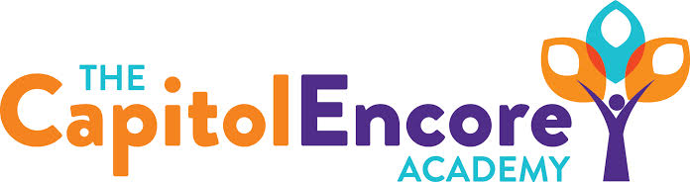

“Learning the Art of Success Every day!”

ENCORE ACADEMY BOARD OF DIRECTORS

Mission Statement
The Capitol Encore Academy will develop artists who inspire others with principles of design and artful thinking through the integration of academic excellence, virtuous character and disciplined artistry.
Agenda

Regular Meeting – January 24, 2022
5:15 PM

Location – The Capitol Encore Academy
126 Hay Street
Fayetteville, NC 28301

Call to Order By: Wendy H. At: 5:15pm

Roll Call R. Poole - Present

J. Fiebig - Present

W. Hustwit - Present

U. Taylor - Absent

R. Serna - Present

Non Board Members Gerard Falls

Contributing Joe Salisbury

Will Kneer

Conflict of Interest Inquiry of any potential COI - None

Pledge of Allegiance

Approval of Agenda Motion to approve the agenda by J. Fiebig, seconded by R. Serna.

Y-4 N-0

Motion Carries

Consent Items Motion to approve the minutes from the December 13, 2021 Regualar Board Meeting by J. Fiebig, seconded by W. Hustwit.

Y-4 N-0

Motion Carries

Motion to approve the December Financials by J. Poole, seconded by J. Fiebig.

Y-4 N-0

Motion Carries

Administration Report Dr. Whitney presented updated AIG plan, summarized changes and discussed the logistics of how the program will be offered.

Covid numbers were presented, 6 close contacts since returning from holiday break, numbers seem to be treanding lower.

Completing mid year testing this week, will continue to evaluate scores as they are complete.

Summary of Dr. Coopers visit will be provided to school by the end of the month, implementing advice she gave on PLCs now.

Discussion Items Discussed Mason St. timeline and challenges. Construction has fallen back 3 weeks due to Covid issues with trade workers. Project costs have risen due to worker shortages and supply chain issues, still within bond amount.

Presented portions of High School enrollment push including HS parent meeting in February, open enrollments strategy and Wood Peckers incentive.

Action Items Motion to approve updated AIG Plan by J. Fiebig, seconded by R. Serna..

Y-4 N-0

Motion Carries

Motion to approve uodated Covid Safety Protocols by R. Serna, seconded by J. Fiebig.

Y-4 N-0

Motion Carries

Call to the Public None

Announcements The next Board of Director’s meeting will be held on January 28, 2022 at 5:15 pm.

Adjournment Motion By: J. Fiebig Seconded By: R. Serna Time: 5:57pm

