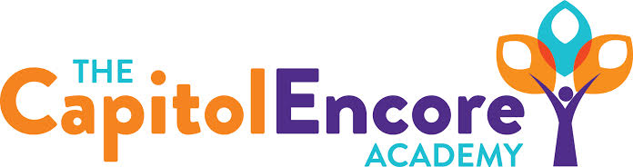

“Learning the Art of Success Every day!”

ENCORE ACADEMY BOARD OF DIRECTORS

Mission Statement
The Capitol Encore Academy will develop artists who inspire others with principles of design and artful thinking through the integration of academic excellence, virtuous character and disciplined artistry.
Minutes

Regular Meeting – October 17, 2022
5:15 PM

Location – The Capitol Encore Academy
200 Mason Street
Fayetteville, NC 28301

Call to Order By: Wendy H. At: 5:15pm

Roll Call R. Poole - Present

J. Fiebig - Absent

W. Hustwit - Present

U. Taylor - Absent

R. Serna - Present

Non Board Members Gerard Falls

Contributing Joe Salisbury

Will Kneer

Conflict of Interest Inquiry of any potential COI - None

Pledge of Allegiance

Approval of Agenda Motion to approve the agenda with amendments by J. Poole, seconded by R. Serna.

Y-3 N-0

Motion Carries

Consent Items Motion to approve the minutes from the September 19, 2022 Regular Board Meeting by R. Serna, supported by W. Hustwit.

Y-3 N-0

Motion Carries

Motion to approve the September financial report by J. Poole, supported by R. Serna.

Y-3 N-0

Motion Carries

Administration Report Updated Board on Financial Audit progress, will be completed and submitted on time.

Discussed challenges/opportunities at both buildings and plans moving forward.

Discussion Items Discussed the charter renewal process and progress towards submittal. Reviewed Academic, Operational, Financial and Educational goals.

Action Items Motion approving hiring of new staff by R. Serna, supported by J. Poole.

Y-3 N-0

Motion Carries.

Call to the Public None

Announcements The next Board of Director’s meeting will be held on November 28, 2022 at 5:15 pm at the Mason St. location.

Adjournment Motion By: W. Hustwit Seconded By: R. Serna Time: 6:03pm

