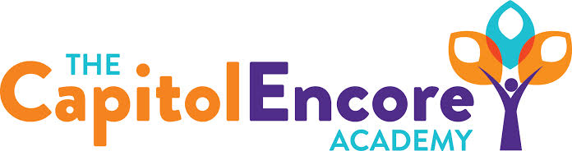

“Learning the Art of Success Every day!”

ENCORE ACADEMY BOARD OF DIRECTORS

Mission Statement
The Capitol Encore Academy will develop artists who inspire others with principles of design and artful thinking through the integration of academic excellence, virtuous character and disciplined artistry.
Agenda

Regular Meeting – December 13, 2021
5:15 PM

Location – The Capitol Encore Academy
126 Hay Street
Fayetteville, NC 28301

Call to Order By: Wendy H. At: 5:15pm

Roll Call R. Poole - Present

J. Fiebig - Present

W. Hustwit - Present

U. Taylor - Present

R. Serna - Present

Non Board Members Gerard Falls

Contributing Joe Salisbury

Will Kneer

Conflict of Interest Inquiry of any potential COI - None

Pledge of Allegiance

Approval of Agenda Motion to approve the agenda by J. Fiebig, seconded by J. Poole.

Y-5 N-0

Motion Carries

Consent Items Motion to approve the minutes from the October 18, 2021 Regualar Board Meeting by J. Poole, seconded by R. Serna

Y-5 N-0

Motion Carries

Motion to approve the October Financials by J. Fiebig, seconded by J. Poole.

Y-5 N-0

Motion Carries

Motion to approve the November Financials by J. Fiebig, seconded by J. Poole.

Y-5 N-0

Motion Carries

Administration Report Discussed a library partnership and MOA with Cumberland County. Dr. Cooper from OCS visited the Academy, she will provide us a report of her observations in January. Dr. Cooper provided some feedback as well as suggestions while on site. Presented potential New Hires.

Discussion Items Discussed the PRC 145 & 203 grants pertaining to staff bonus structures. Discussed and presented the findings from the ESSER/GEER audit. Reviewed Covid safety protocol updates. Discussed TCEA’s position on the Low Performing Schools list and the lack of possibility to come off of that list based on canceled state testing. Gave update on Mason St. renovation and planning for High School roll out. January 10 there is a HS parents meeting for 8th and 9th grade families.

Action Items Motion to approve proposed New Hires by J. Poole, seconded by J. Fiebig.

Y-5 N-0

Motion Carries

Motion to approve uodated Covid Safety Protocols by R. Serna, seconded by W. Hustwit.

Y-5 N-0

Motion Carries

Call to the Public Employee brought to the Board’s attention that not all teachers are included in the bonus structure through DPI.

Announcements The next Board of Director’s meeting will be held on January 24, 2022 at 5:15 pm.

Adjournment Motion By: J. Fiebig Seconded By: R. Serna Time: 6:07pm

