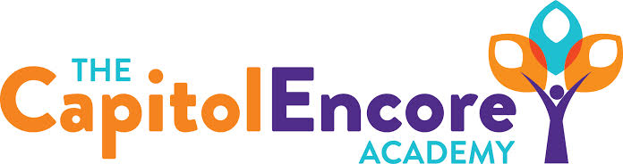

“Learning the Art of Success Every day!”

ENCORE ACADEMY BOARD OF DIRECTORS

Mission Statement
The Capitol Encore Academy will develop artists who inspire others with principles of design and artful thinking through the integration of academic excellence, virtuous character and disciplined artistry.
Minutes

Regular Meeting – February 13, 2023
5:15 PM

Location – The Capitol Encore Academy
200 Mason Street
Fayetteville, NC 28301

Call to Order By: Wendy H. At: 5:15pm

Roll Call R. Poole - Present

J. Fiebig - Present (Phone)

W. Hustwit - Present

U. Taylor - Absent

R. Serna - Absent

Conflict of Interest Inquiry of any potential COI - NONE

Pledge of Allegiance

Approval of Agenda Motion to approve the agenda as present by J. Poole, seconded by W. Hustwit.

Y-3 N-0

Motion Carries

Consent Items Motion to approve the minutes from the January 23, 2023 Regular Meeting by J. Fiebig, seconded by J. Poole.

Y-3 N-0

Motion Carries

Motion to approve the January Financial Report by J. Poole, seconded by J. Fiebig.

Y-3 N-0

Motion Carries

Administration Report Data was presented to the board from the MOY testing that was completed. Also shared projections of data based on where students have grown. Discussed the replacement sixth grade science postion while proposing a teacher. Discussed the charter renewal visit on April 26, talking about needing 3 sets of interviewees lined up.

Action Items Motion to approve New Hire, Mr. Kartsen Ray for 6th grade science by J. Fiebig, seconded by J. Poole.

Y-3 N-0

Motion Carries

Call to the Public None

Announcements The next Board of Director’s meeting will be held on March 20, 2023 at 5:15 pm.

Adjournment Motion By: J. Fiebig Seconded By: J. Poole Time: 5:56pm

