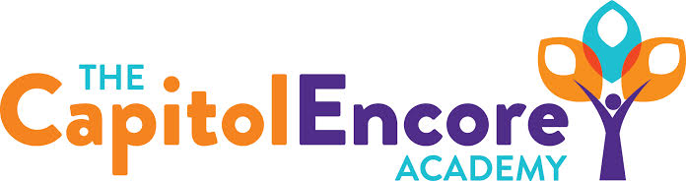

“Learning the Art of Success Every day!”

ENCORE ACADEMY BOARD OF DIRECTORS

Mission Statement
The Capitol Encore Academy will develop artists who inspire others with principles of design and artful thinking through the integration of academic excellence, virtuous character and disciplined artistry.
Agenda

Regular Meeting – February 28, 2022
5:15 PM

Location – The Capitol Encore Academy
126 Hay Street
Fayetteville, NC 28301

Call to Order By: Wendy H. At: 5:15pm

Roll Call R. Poole - Present

J. Fiebig - Present

W. Hustwit - Present

U. Taylor - Present (5:30pm via Zoom)

R. Serna - Present

Non Board Members Gerard Falls

Contributing Joe Salisbury

Will Kneer

Ashley Brunner

Conflict of Interest Inquiry of any potential COI - None

Pledge of Allegiance

Approval of Agenda Motion to approve the agenda by J. Poole, seconded by R. Serna.

Y-4 N-0

Motion Carries

Consent Items Motion to approve the minutes from the January 2022 Regular Board Meeting by J. Fiebig, seconded by R. Serna.

Y-4 N-0

Motion Carries

Motion to approve the January Financials by J. Fiebig, seconded by J. Poole

Y-4 N-0

Motion Carries

Administration Report Mr. Salisbury presented the proposed FY23 calendar, summarizing the similarities and differences to Cumberland County. Mr. Falls discussed the proposed summer school schedule. Staff intent forms were returned with a 100% wishing to return rate amongst staff. Ms. Brunner discussed the EOG data from the 21-22 school year and showed the comparison to Cumberland County and the state. Data was also shown for subgroups.

Discussion Items Discussed Mason St. renovation, giving a possible Occupancy date of May 14^{th,} 2022. Lockers have been delivered and are stored on site. Mr. Fiebig mentioned a grant written to Cumberland County in the amount of $765,000 to do additional work at the Arch St. location.

Presented the High School planning updates, including what type of advertising that will take place to help push enrollment. Mentioned that we currently have a few teachers, including Math, that want to transition to high school.

Discussed the current COVID policies and shared the new state and CDC guidance.

Action Items Motion to approve FY23 Calendar by J. Fiebig, seconded by R. Serna.

Y-5 N-0

Motion Carries

Motion to approve updated Covid School Safety Plan, effective immediately, by J. Poole, seconded by J. Fiebig.

Y-5 N-0

Motion Carries

Motion to approve Summer School Schedule by J. Fiebig, seconded by R. Serna.

Y-5 N-0

Motion Carries

Call to the Public Staff Member asked about the use of water fountains and what can be done due to the number of students who forget their bottles.

Announcements The next Board of Director’s meeting will be held on March 21, 2022 at 5:15 pm.

Adjournment Motion By: J. Fiebig Seconded By: R. Serna Time: 6:25pm

