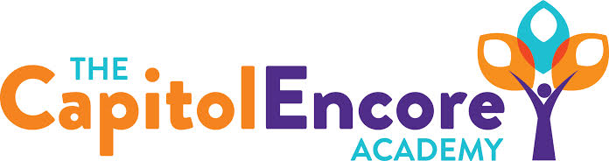

“Learning the Art of Success Every day!”

ENCORE ACADEMY BOARD OF DIRECTORS

Mission Statement
The Capitol Encore Academy will develop artists who inspire others with principles of design and artful thinking through the integration of academic excellence, virtuous character and disciplined artistry.
Minutes

Regular Meeting – March 20, 2023
5:15 PM

Location – The Capitol Encore Academy
200 Mason Street
Fayetteville, NC 28301

Call to Order By: Wendy H. At: 5:15pm

Roll Call R. Poole - Present

J. Fiebig - Present

W. Hustwit - Present

U. Taylor - Absent

R. Serna - Present

Non Board Members W. Kneer

Contributing J. Salisbury

K. Whitney

Conflict of Interest Inquiry of any potential COI- None

Pledge of Allegiance

Approval of Agenda Motion to approve the agenda as present by J. Fiebig, supported by R. Serna.

Y-4 N-0

Motion Carries

Consent Items Motion to approve the minutes from the February 13, 2023 Regular Meeting by J. Fiebig, supported by R. Serna.

Y-4 N-0

Motion Carries

Motion to approve the February Financial Report by J. Poole, supported by J. Fiebig.

Y-4 N-0

Motion Carries

Administration Report The School Nutrition Administration Review is complete and went well. Summer School will be June 12-30, Discussed the Department of Education Logitudinal Study. Student Council presented proposed changes to dress code, caffinated beverages and cell phone policy. The Board asked questions and indicated that they would discuss more at a further date and get back to students.

Discussion Items Proposed School Calendar for 23-24 School year. Reviewed current Internet Policy and made proposed changes to meet the guidelines for Title 17 child protection. Poposed a New Hire for 7th grade math. Dr. Whitney presented our proposed Credit Recovery Program.

Action Items Motion to approve 23-24 Calendar by J. Fiebig, supported by R. Serna.

Y-4 N-0

Motion Carries

Motion to adopt amended Internet Policy by R. Serna, supported by J. Poole.

Y-4 N-0

Motion Carries

Motion to approve the hiring of new staff by J. Poole, supported by J. Fiebig.

Y-4 N-0

Motion Carries

Motion to approve the Summer Program as presented by J. Fiebig, supported by R. Serna.

Y-4 N-0

Motion Carries

Call to the Public None

Announcements The next Board of Director’s meeting will be held on April 17, 2023 at 5:15 pm.

Adjournment Motion By: J. Fiebig Seconded By: J. Poole Time: 6:43pm

