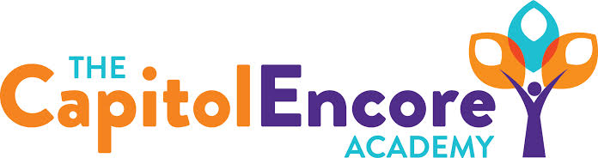

“Learning the Art of Success Every day!”

ENCORE ACADEMY BOARD OF DIRECTORS

Mission Statement
The Capitol Encore Academy will develop artists who inspire others with principles of design and artful thinking through the integration of academic excellence, virtuous character and disciplined artistry.
Minutes

Regular Meeting – March 21, 2022
5:15 PM

Location – The Capitol Encore Academy
126 Hay Street
Fayetteville, NC 28301

Call to Order By: Wendy H. At: 5:15pm

Roll Call R. Poole - Present

J. Fiebig - Present

W. Hustwit - Present

U. Taylor - Absent

R. Serna - Present

Non Board Members Gerard Falls

Contributing Joe Salisbury

Will Kneer

Conflict of Interest Inquiry of any potential COI - None

Pledge of Allegiance

Approval of Agenda Motion to approve the agenda by J. Fiebig, seconded by R. Serna.

Y-4 N-0

Motion Carries

Consent Items Motion to approve the minutes from the February 2022 Regular Board Meeting by R. Serna, seconded by J. Poole.

Y-4 N-0

Motion Carries

Motion to approve the February Financials by R. Serna, seconded by J. Poole

Y-4 N-0

Motion Carries

Administration Report Reviewed NC Check in data; the positive effects of EBLI are evident in K-2, data trends lead us to be cautiously confident for EOGs.

Current enrollment for FY23 shows K-6 are at an all time high, 10th grade enrollment is higher than anticipated. Potentially will open additional classes in 1st and 6th grade. We have 137 new applicants which is a substantial increase from years past.

Initial staff interviews have began, we have 14 new positions open for FY23.

Discussion Items Mason Street Building update; final inspections are underway and final work is being completed. Expectations are that by the end of April we will be close to receiving a Certificate of Occupancy.

Action Items None

Call to the Public None

Announcements The next Board of Director’s meeting will be held on April 25, 2022 at 5:15 pm.

Adjournment Motion By: J. Fiebig Seconded By: R. Serna Time: 6:02pm

