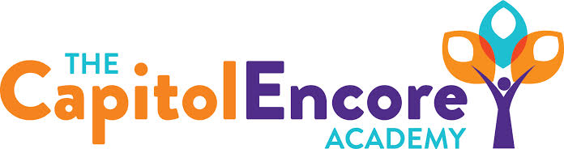

“Learning the Art of Success Every day!”

ENCORE ACADEMY BOARD OF DIRECTORS

Mission Statement
The Capitol Encore Academy will develop artists who inspire others with principles of design and artful thinking through the integration of academic excellence, virtuous character and disciplined artistry.
Minutes

Regular Meeting – April 25, 2022
5:15 PM

Location – The Capitol Encore Academy
126 Hay Street
Fayetteville, NC 28301

Call to Order By: Wendy H. At: 5:15pm

Roll Call R. Poole - Absent

J. Fiebig - Present

W. Hustwit - Present

U. Taylor - Present 5:35

R. Serna - Present

Non Board Members Gerard Falls

Contributing Joe Salisbury

Will Kneer

Conflict of Interest Inquiry of any potential COI - None

Pledge of Allegiance

Approval of Agenda Motion to approve the agenda by J. Fiebig, seconded by R. Serna.

Y-3 N-0

Motion Carries

Consent Items Motion to approve the minutes from the March 2022 Regular Board Meeting by J. Fiebig, seconded by R. Serna.

Y-3 N-0

Motion Carries

Motion to approve the March Financials by J. Fiebig, seconded by R. Serna.

Y-3 N-0

Motion Carries

Administration Report Held enrollment lottery with the updated process. We have wait lists in K,1,2,5,6 & 7th grade. Total enrollment for FY23 currently sits at 727.

Offer letters for returning staff to be distributed by the end of the week, intent forms show 100% would like to return.

2nd round of interviews are slated to begin this week for new open positions.

Discussion Items Expecting the Certificate of Occupancy to be available around May 20th, PWC needs to install meter.

June 3rd is our last day with students. 8th grade graduation slated to be held at the Mason St. site.

Action Items None

Call to the Public None

Announcements The next Board of Director’s meeting will be held on May 16th, 2022 at 5:15 pm.

Adjournment Motion By: W. Hustwit Seconded By: U. Taylor Time: 5:58pm

