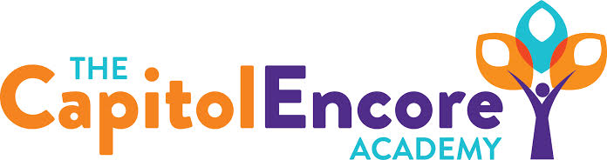

“Learning the Art of Success Every day!”

ENCORE ACADEMY BOARD OF DIRECTORS

Mission Statement
The Capitol Encore Academy will develop artists who inspire others with principles of design and artful thinking through the integration of academic excellence, virtuous character and disciplined artistry.
Minutes

Regular Meeting – May 16, 2022
5:15 PM

Location – The Capitol Encore Academy
126 Hay Street
Fayetteville, NC 28301

Call to Order By: Wendy H. At: 5:15pm

Roll Call R. Poole - Present

J. Fiebig - Present

W. Hustwit - Present

U. Taylor - Absent

R. Serna - Absent

Non Board Members Gerard Falls

Contributing Joe Salisbury

Conflict of Interest Inquiry of any potential COI - None

Pledge of Allegiance

Approval of Agenda Motion to approve the agenda by J. Fiebig, seconded by J. Poole

Y-3 N-0

Motion Carries

Consent Items Motion to approve the minutes from Aprill 2022 Board Meeting by J. Fiebig, seconded by J. Poole

Y-3 N-0

Motion Carries

Motion to approve the April Financials by J. Poole, seconded by W. Hustwit

Y-3 N-0

Motion Carries

Administration Report Enrollment still strong for 2022-23. Currently waitlists in all grades but 8th, 9th, 10th. Working on getting new students paperwork turned in.

iReady data looks good. 100% Math growth and 102% ELA growth. This looks good for EOGs

Discussed still open positions for the 2022-23 school year, mainly needing to focus on Math/Science hiring. Presented 3 new hires to Board.

Expecting Certificate of Occupancy for Mason St in early June.

Discussion Items Discussed issues with contracted entity and processes that will be put in place to ensure that 3rd party contracts are vetted properly for the safety of students.

Action Items Motion to approve the new hires by J. Fiebig, seconded by J. Poole

Y-3 N-0

Motion Carries

Call to the Public None

Announcements The next Board of Director’s meeting will be held on June 20th, 2022 at 5:15 pm.

Adjournment Motion By: J. Fiebig Seconded By: W. Hustwit Time: 5:50pm

