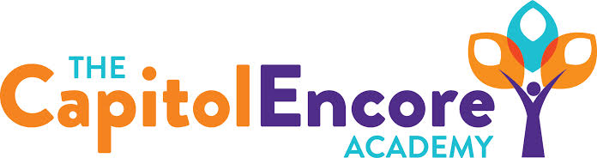

“Learning the Art of Success Every day!”

ENCORE ACADEMY BOARD OF DIRECTORS

Mission Statement
The Capitol Encore Academy will develop artists who inspire others with principles of design and artful thinking through the integration of academic excellence, virtuous character and disciplined artistry.
Minutes

Regular Meeting – June 20, 2022
5:15 PM

Location – The Capitol Encore Academy
126 Hay Street
Fayetteville, NC 28301

Call to Order By: Wendy H. At: 5:32pm

Roll Call R. Poole - Present

J. Fiebig - Present

W. Hustwit - Present

U. Taylor - Absent

R. Serna - Present

Non Board Members Gerard Falls

Contributing Joe Salisbury

Will Kneer

Conflict of Interest Inquiry of any potential COI - None

Pledge of Allegiance

Approval of Agenda Motion to approve the agenda by J. Poole, seconded by J. Fiebig.

Y-4 N-0

Motion Carries

Consent Items Motion to approve the minutes from the May 2022 Regular Board Meeting by R. Serna, seconded by J. Poole.

Y-4 N-0

Motion Carries

Motion to approve the May Financials by J. Fiebig, seconded by J. Poole.

Y-4 N-0

Motion Carries

Administration Report Staffing update- Have created offer letters for EC, 1st grade, Social Studies, Music and Math positions.

Enrollment update- We have 456 new applications, waitlist in every grade except for 9 & 10.

TWC Survey- 3 biggest concerns to address are: teacher leadership opportunities, student bullying and bathroom cleanliness.

Discussion Items Mason St. update- Expect to have final C of O by the end of the week.

Presented proposed FY22 amendments

Discussed having a Board committee to approve handbook and uniform changes.

Proposed FY23 Board meeting dates are: 8/15, 9/19, 10/17, 11/28, 1/23, 2/13, 3/20, 4/17, 5/15 & 6/12

Action Items Motion to adopt FY23 Budget as presented in the Budget Hearing by J. Fiebig, supported by J. Poole.

Y – 4 N – 0

Motion carries

Motion approving FY22 Budget Amendments by J. Fiebig, supported by J. Poole.

Y – 4 N – 0

Motion carries

Motion adopting FY23 Board Dates as presented by J. Fiebig, supported by R. Serna.

Y – 4 N – 0

Motion carries

Motion approving Student Handbook committee by J. Poole, supported by J. Fiebig.

Y – 4 N – 0

Motion carries

Call to the Public None

Announcements The next Board of Director’s meeting will be held on August 15th, 2022 at 5:15 pm.

Adjournment Motion By: W. Hustwit Seconded By: J. Fiebig Time: 6:19pm

