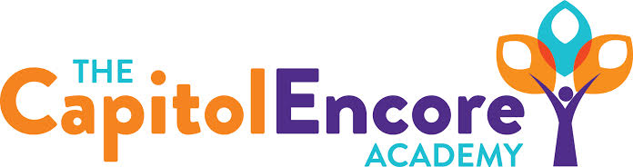

“Learning the Art of Success Every day!”

ENCORE ACADEMY BOARD OF DIRECTORS

Mission Statement
The Capitol Encore Academy will develop artists who inspire others with principles of design and artful thinking through the integration of academic excellence, virtuous character and disciplined artistry.
Minutes

Regular Meeting – September 19, 2022
5:15 PM

Location – The Capitol Encore Academy
126 Hay Street
Fayetteville, NC 28301

Call to Order By: Wendy H. At: 5:15pm

Roll Call R. Poole - Present

J. Fiebig - Present

W. Hustwit - Present

U. Taylor - Present

R. Serna - Present

Non Board Members Gerard Falls

Contributing Joe Salisbury

Will Kneer

Conflict of Interest Inquiry of any potential COI - None

Pledge of Allegiance

Approval of Agenda Motion to approve the agenda with amendments by J. Fiebig, seconded by U. Taylor.

Y-5 N-0

Motion Carries

Consent Items Motion to approve the minutes from the August 15, 2022 Regular Board Meeting by J. Poole, supported by J. Fiebig.

Y-5 N-0

Motion Carries

Motion to approve the June, July & August financial reports by J. Fiebig, supported by W. Hustwit.

Y-5 N-0

Motion Carries

Administration Report Staffing update- Filled the open Math and MTSS positions.

School year update- Off to a strong start. Things are running smoothly at both buildings, arrival/dismissal only took a couple days to run smoothly. Both enrollment and staffing are going well, supplies and materials have all arrived.

Will give EOG update in October.

Discussion Items Discussed NC Star and our continued use of the program and data.

Action Items Motion approving hiring of new staff by J. Poole, supported by J. Fiebig.

Y-5 N-0

Motion Carries.

Call to the Public None

Announcements The next Board of Director’s meeting will be held on September 19th, 2022 at 5:15 pm at the Mason St. location.

Adjournment Motion By: J. Fiebig Seconded By: J. Poole Time: 5:54pm

