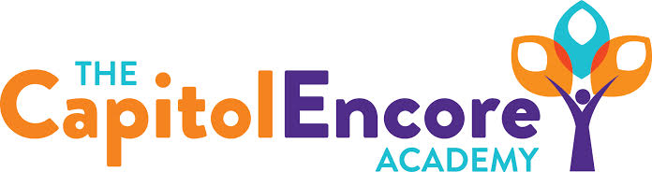

“Learning the Art of Success Every day!”

ENCORE ACADEMY BOARD OF DIRECTORS

Mission Statement
The Capitol Encore Academy will develop artists who inspire others with principles of design and artful thinking through the integration of academic excellence, virtuous character and disciplined artistry.
Minutes

Regular Meeting – April 17, 2023
5:15 PM

Location – The Capitol Encore Academy
200 Mason Street
Fayetteville, NC 28301

Call to Order By: Wendy H. At: 5:15pm

Roll Call R. Poole - Absent

J. Fiebig - Present - Phone

W. Hustwit - Present

U. Taylor - Present

R. Serna - Present - Phone

Contributing Non G. Falls

Board Members J. Salisbury

Conflict of Interest Inquiry of any potential COI - NONE

Pledge of Allegiance

Approval of Agenda Motion to approve the agenda as presented by R. Serna, supported by W. Hustwit.

Y-3 N-0

Motion Carries

Consent Items Motion to approve the minutes from the March 20, 2023 regular meeting by J. Fiebig, supported by W. Hustwit.

Y-3 N-0

Motion Carries

Motion to approve of the March Financial Report by R. Serna, supported by W. Hustwit.

Y-3 N-0

Motion Carries

Administration Report Administration gave an update on the enrollment for 23-24. Currently have 341 applications along with 584 re-enrollees. There are wait lists in grades K-8. High School enrollment is lagging behind at this time. To help promote high school enrollment, TCEA is partnering with Guy Unger to begin a contemporary band program for high school. Administration also discussed the 3 non-renewals for staff and the 1 that’s being held, depending on grade level structure for next year. Admin also mentioned the Title I audit to happen on April 19th, on site.

Discussion Items The Board discussed the student council presentation, adding that they needed to develop the ideas better. The charter renewal visit for April 26th was also mentioned, while also saying that a schedule hasn’t been received yet.

Action Items NONE

Call to the Public Public Member stated that the theater program for the high school is amazing.

Announcements The next Board of Director’s meeting will be held on May 15, 2023 at 5:15 pm.

Adjournment Motion By: J. Fiebig Seconded By: R. Serna Time: 5:45pm

