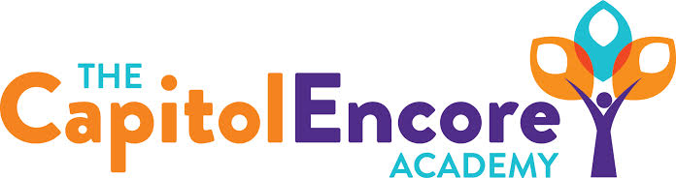

“Learning the Art of Success Every day!”

ENCORE ACADEMY BOARD OF DIRECTORS

Mission Statement
The Capitol Encore Academy will develop artists who inspire others with principles of design and artful thinking through the integration of academic excellence, virtuous character and disciplined artistry.
Minutes

Regular Meeting – June 12, 2023
5:15 PM

Location – The Capitol Encore Academy
200 Mason Street
Fayetteville, NC 28301

Call to Order By: Wendy H. At: 5:29pm

Roll Call R. Poole - Present

J. Fiebig - Absent

W. Hustwit - Present

U. Taylor - Absent

R. Serna - Present

Contributing Non G. Falls

Board Members J. Salisbury

W. Kneer

Conflict of Interest Inquiry of any potential COI - NONE

Pledge of Allegiance

Approval of Agenda Motion to approve the agenda as presented by R. Serna, supported by J. Poole.

Y-3 N-0

Motion Carries

Consent Items Motion to approve the minutes from the May 15, 2023 regular meeting by J. Poole, supported by R. Serna.

Y-3 N-0

Motion Carries

Motion to approve of the May Financial Report by R. Serna, supported by J. Poole.

Y-3 N-0

Motion Carries

Administration Report Discussed proposed changes to both the staff and student handbooks for FY24. Enrolllment update, 477 new applications. HS grades are most difficult to fill. Summer School offering is in progress and will run through the end of June. Proposed new hire candidtes in the areas of theatre, visual arts, 1st, 5th & HS English. Preliminary testing data looks somewhat promising for both growth and proficiency.

Discussion Items Presented and discussed final amendments to the FY23 budget. Discussed and proposed FY24 Board meeting dates as: 8/14, 9/18, 10/23, 11/13, 12/18, 1/22, 2/26, 3/18, 4/22, 5/20, 6/24

Discussed and proposed Board position and terms as President- W. Hustwit, VP- R. Serna, Secretary- U. Taylor, Treasurer, J. Poole. J. Poole 3 years, J. Fiebig 2 years.

Discussed and clarified Title IX review and designee. Discussed the designee for Title IX, FOIA, 504 and MV be G. Falls or a staff member he designates. Discussed and disseminated the Conflict of Interest Disclosure. Discussed the National Charter School Institute required Board Policies and Board Member Acknoledgement of State/Federal guidelines. Discussed potential amendedments to Bylaws. Discussed Office of Charter Schools Board trainings. The Student Council Board Subcommitte reported to the Board on recommendations resulting from Student Council presentation. Discussed Website transparency and updates.

Action Items Motion to amend the FY23 budget as discussed by R. Serna, supported by J. Poole.

3 – Y 0 – N

Motion Carries

Motion to approve staff and student handbooks by J. Poole, supported by R. Serna

3 – Y 0 – N

Motion Carries

Motion to adopt the FY24 Board meeting dates as discuused by R. Serna, supported by J. Poole

3 – Y 0 – N

Motion to approve the Amendment of Bylaws as discussed by J. Poole, supported by R. Serna

3 – Y 0 – N

Motion Carries

Motion appointing designee for FOIA, Title IX, 504 and Title VII-B of the McKinney Vento Homeless Assistance Act by R. Serna, supported by J. Poole.

3 – Y 0 – N

Motion Carries

Motion to approve the New Hires as presented by J. Poole, supported by R. Serna

3 – Y 0 – N

Motion Carries

Motion to adopt the FY24 Budget as presented in the Budget Hearing by R. Serna, supported by J. Poole.

3 – Y 0 – N

Motion Carries

Call to the Public None

Announcements The next Board of Director’s meeting will be held on August 14, 2023 at 5:15 pm.

Adjournment Motion By: R. Serna Seconded By: J. Poole Time: 6:43pm

